Golang

Udemy : <https://cisco.udemy.com/course/go-the-complete-developers-guide/learn/lecture/7817382#overview>

**Link to Completed Code**

<https://github.com/StephenGrider/GoCasts>

<https://www.youtube.com/watch?v=ii3kYuPN2D0&list=PLsyeobzWxl7pJ9Gy1iHRKjUTE5xPhJ18b&index=2>

<https://www.golangprograms.com/go-language/variables.html>

<https://play.golang.org/>

**Section 1:) Getting Started**

**Environment setup**

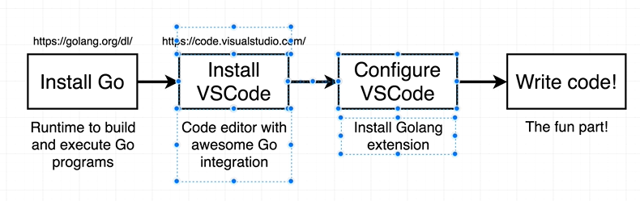

**Go runtime installer :** [**https://golang.org/dl/**](https://golang.org/dl/)

**Vscode installer :** code.visualstudio.com

**Go support in vs code : view -extension -go**

Section 2 :) Simple Start

Note :

Explorer tab allow to work all folder and directory

fmt and string passing in Println function must be in double quote and Printf( P is cap)

Shift+alt+f ----- for format code

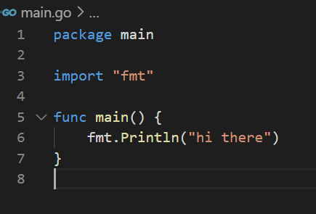

Note : main function will execute automatically

Five basic question

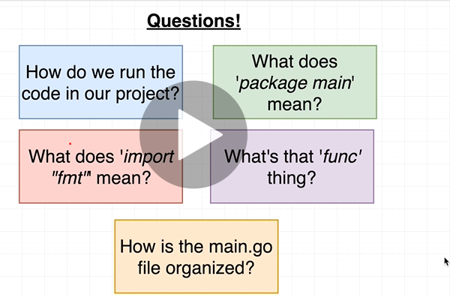

Q1) How to run go code : **go run main.go**

**note**

Select View : terminal in vs code

Go command has the ability to compile and execute it

Run as administrator visual studio

**Go build main.go** will compile our file not execute it and it will create main.exe

**To run main.exe :-** ./main.exe

**Go build : compiles the file**

**Go run : compiles and execute it**

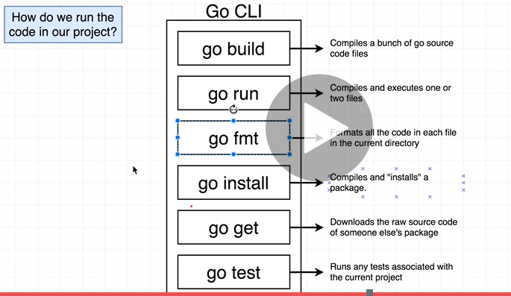

Go Package

A package is a collection of common source code file

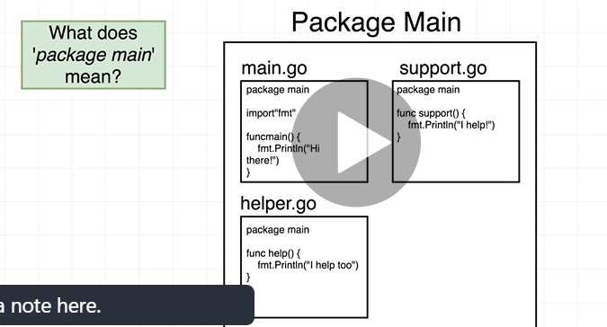

**Note : inside go there are two types of packages**

1. **Eexcutable**
2. **Reusable ( code dependency or logic put here not executable)**

**That depends on name of the package**

**If we use word main :------ then executable package**

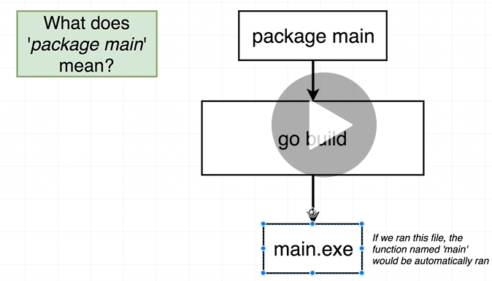

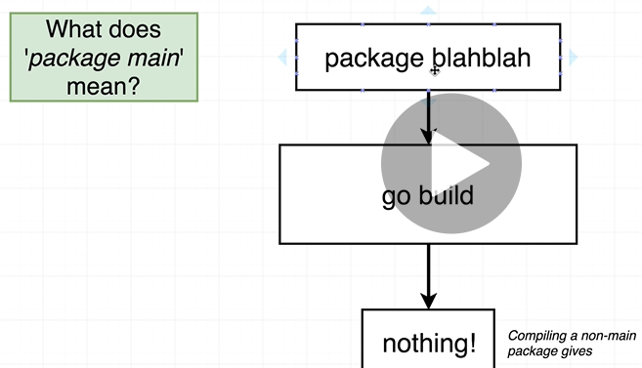

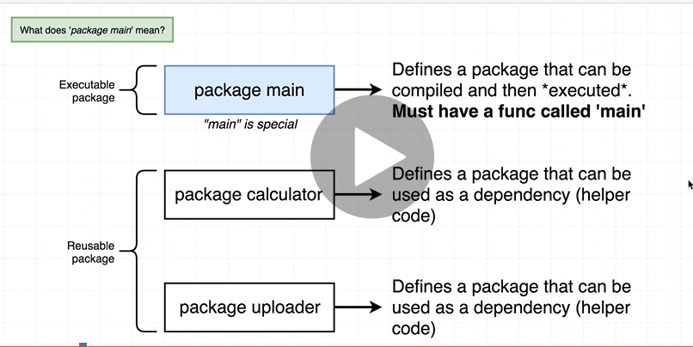

**Import Statement**

**Import "fmt"** means it allow main package to access all the functionalities of another package

Import allow to access another package

Fmt is short form of word format

**Note : by default main package does not have access to any other package.**

To use other package we have to especially use import statement

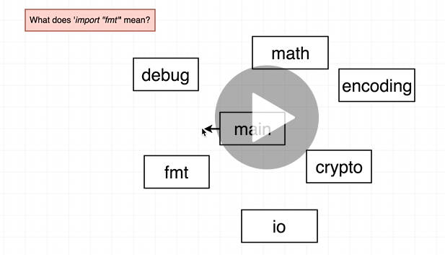

We can import reusable package also

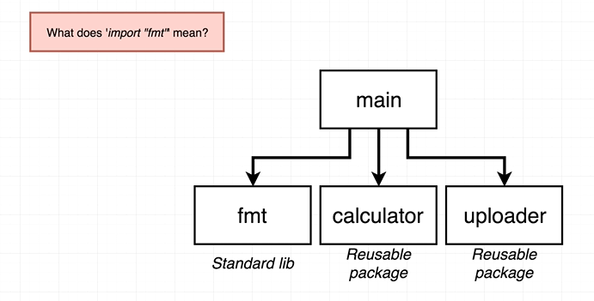

File Organizations

Note :

The main() function is the entry point of an executable program in Go. It is the first thing that is invoked when you run an executable program.

func is short form of function in go

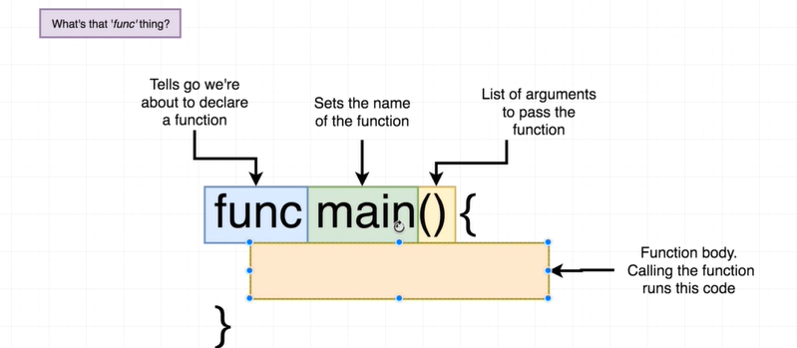

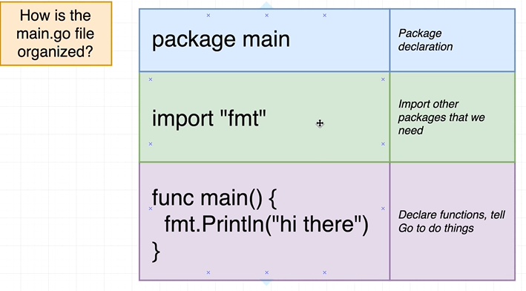

 **Section 3:) Deeper into GO**

**Project Overview**

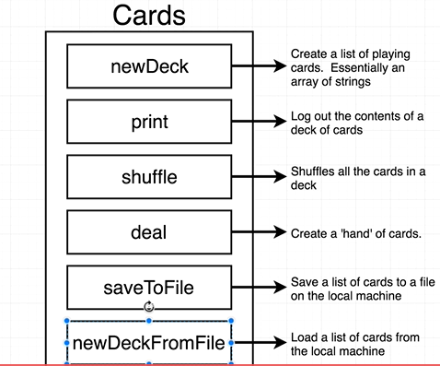

**New Project Folder**

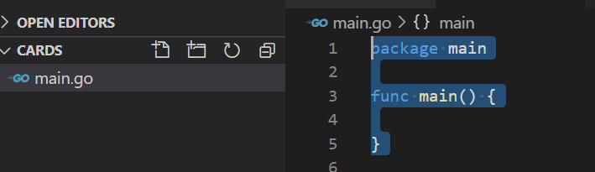

**Variable declaration**

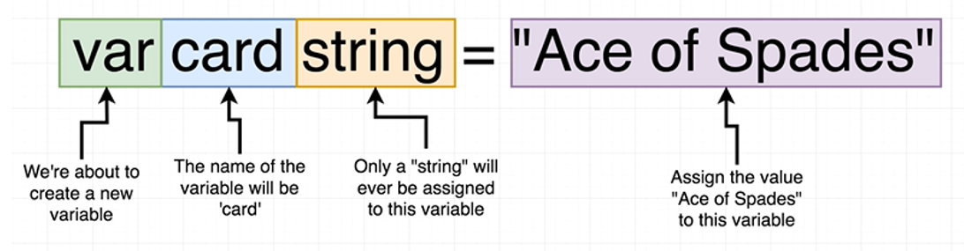

**We need to define variable type in go**

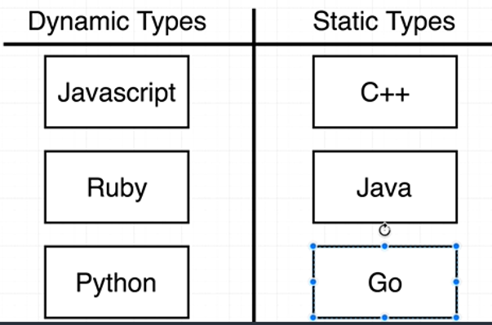

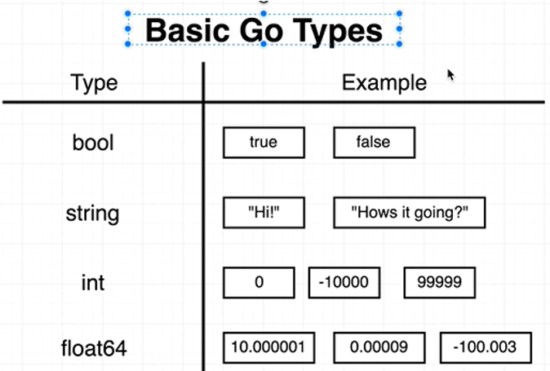

**Note : we will use := only very first time for initializing the value.**

**Second time we will not use it ( means we can assign new value to existing variable)**

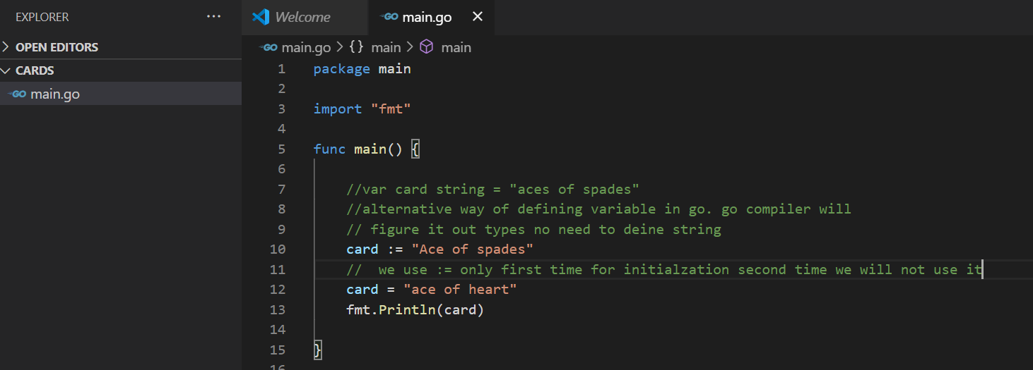

**NOTE:**

**We can initialize and then later assign a value to a variable**

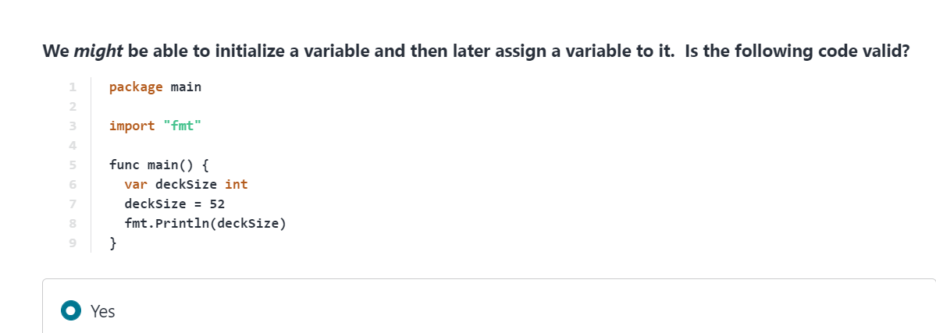

**Variables must first be initialized with the ':=' operator or the 'var variableName type' syntax**

**Important :**

**:= only works in functions**

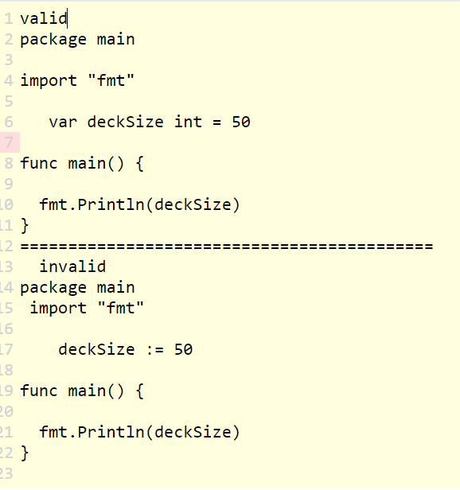

Function and return types

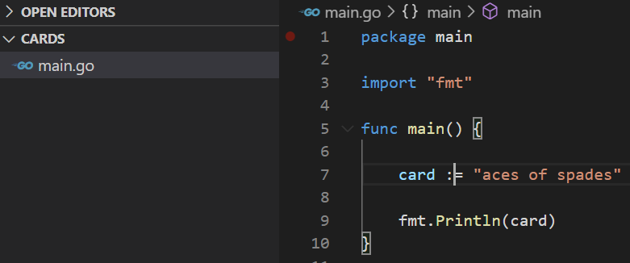

**Requirement :** call a separate function that will return ace of spades

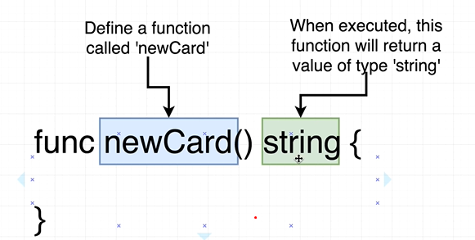

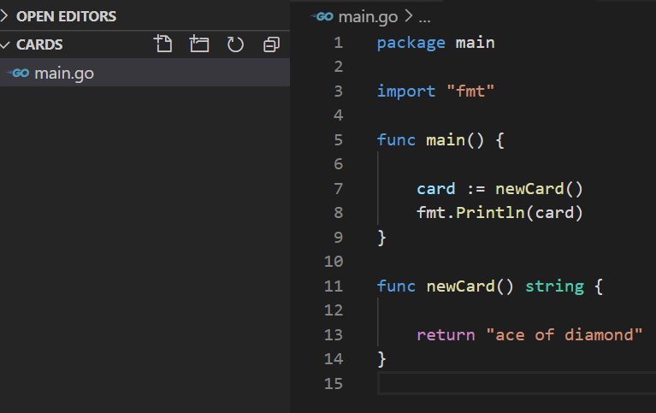

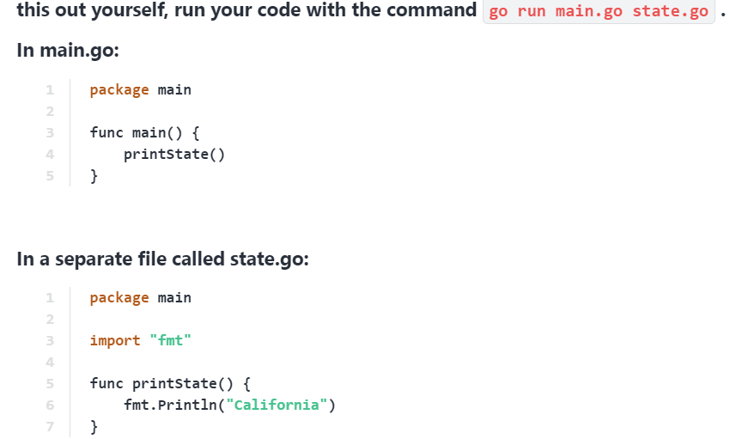

// output : - california

Slice and For loops

Note :

in above example we created a single card but requirement is to create a deck of card ( like 20,30 etc)

Solution : required data structure or list to handle it

**Note : slice is an array in go that can grow or shrink**

**Declaring slice :---- [] return type {}**

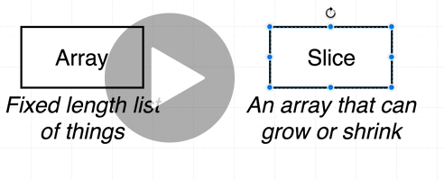

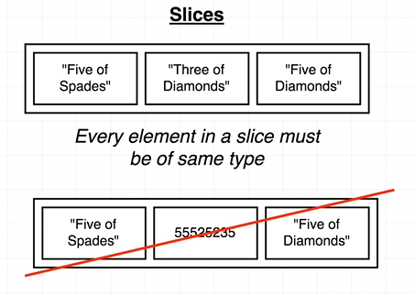

**Requirement : create multiple card using slice**

**Note : range is keyword when we to iterate over slice**

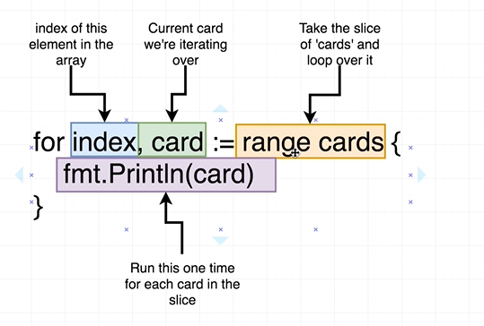

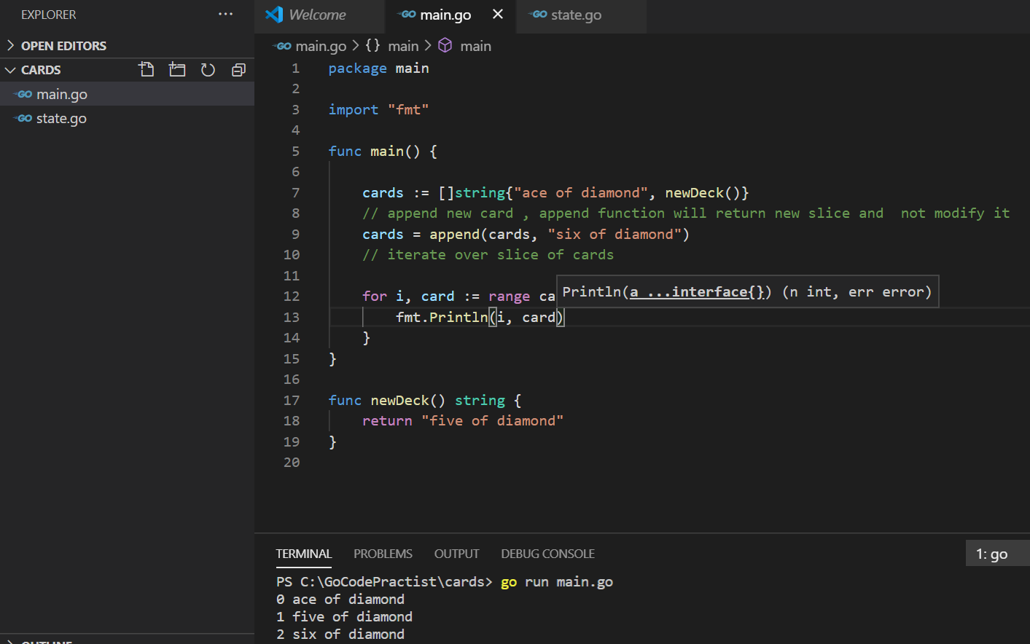

**OO Approach vs GO approach**

**NOTE : go is not a oops language so there is no idea of classes**

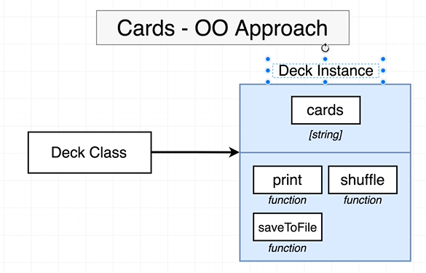

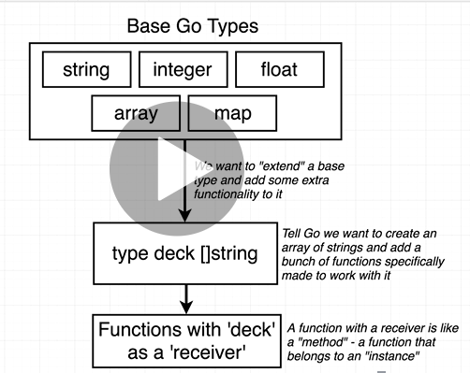

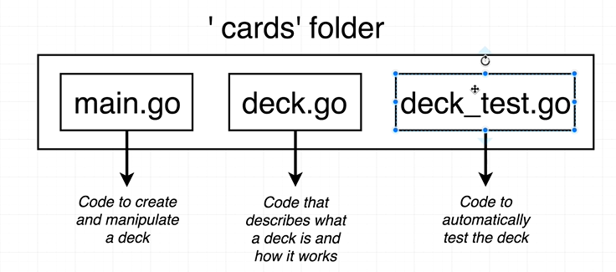

**Custom type declaration**

Note :

Deck type will give extra functionality to work with function

**Type deck [] string ------**deck type borrows all behavior of string

Deck type is equal to all behavior as slice of string

Declare a new type that extends existing type

**Requirement : replacing slice of string with deck type**

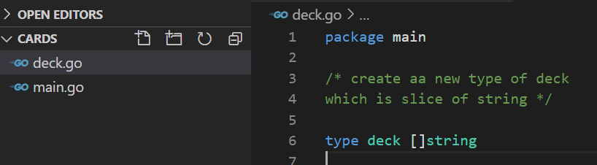

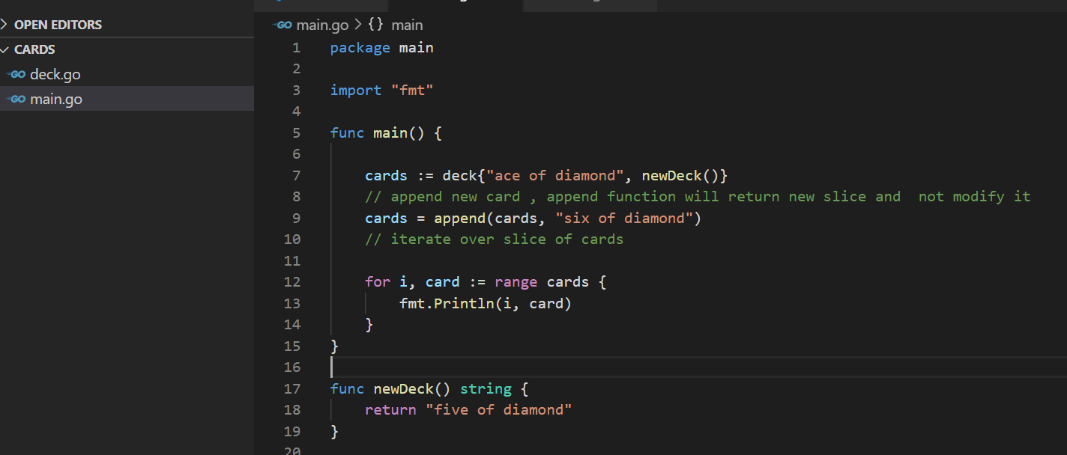

**Question : why we created deck type**

**Receiver function**

**imp :Receiver set up method on variable that we create**

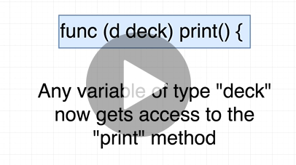

**Very imp:**

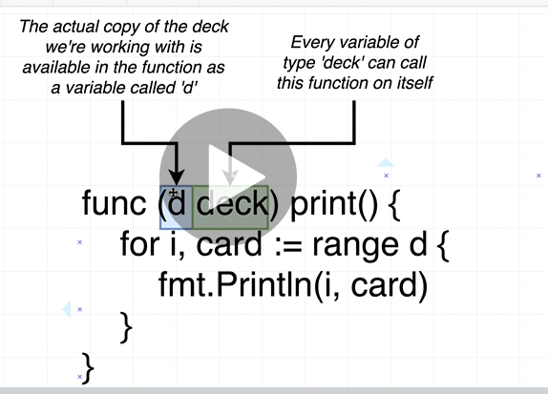

D is instance of actual variable that we are working with

Receiver use to call a method on deck type variable and it will get the reference of variable

To invoke a method on variable of deck type: receiver

Note : d is similar to this

**Current deck type reference will go to receiver function**

**Note : Type and receiver method and we call receiver method on deck type variable**

**Thinks like type----class receiver----method -------calling method on deck type variable**

**Example**

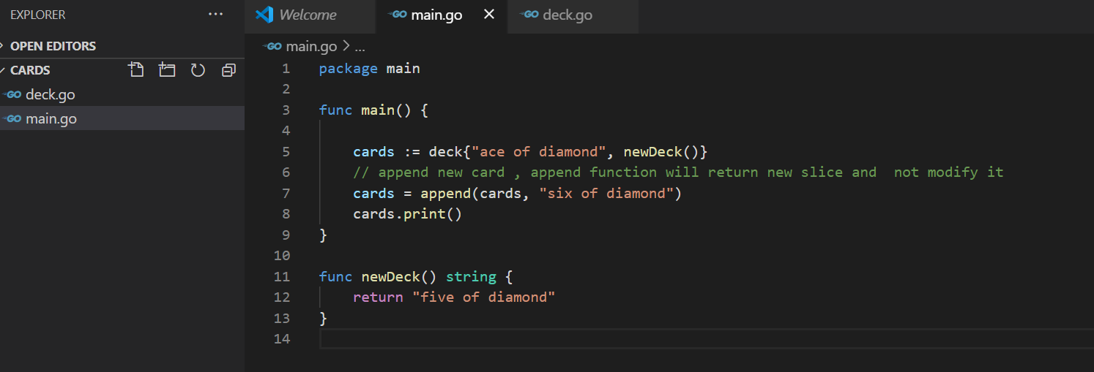

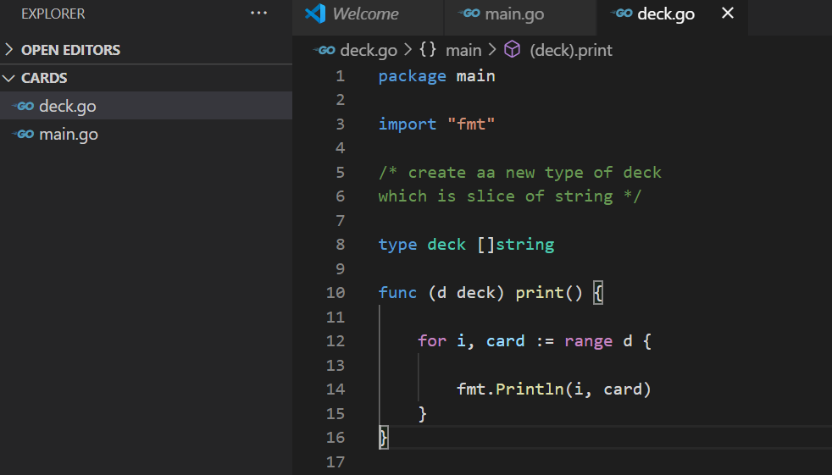

**Output**

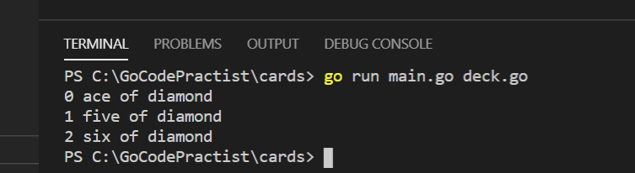

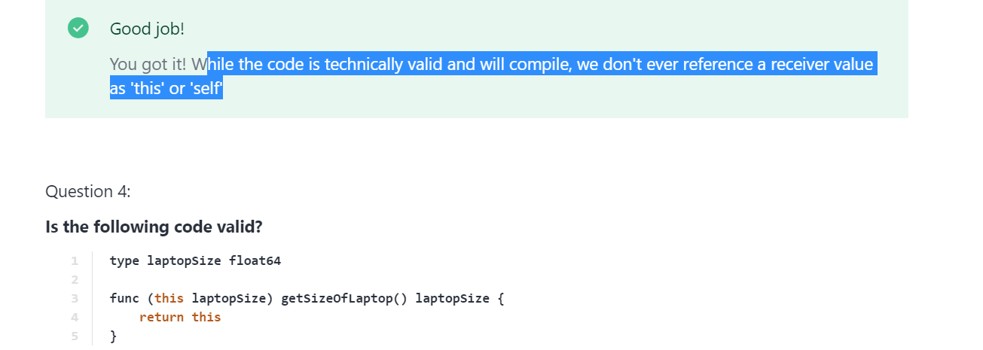

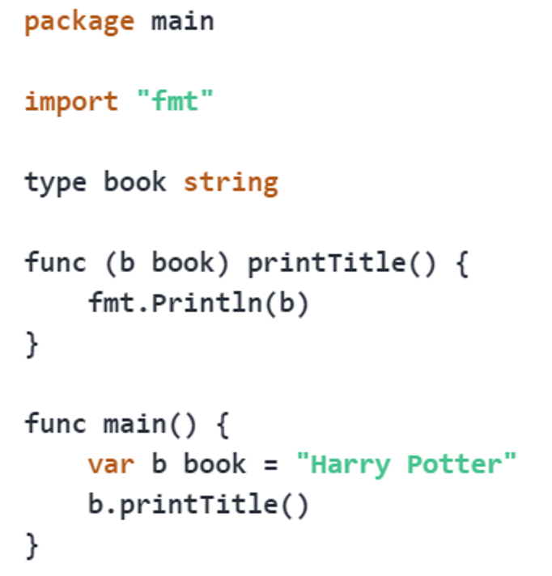

**Creating a new DECK**

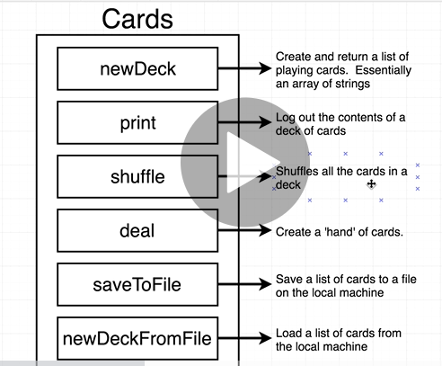

**Follows below approach to create a newDeck**

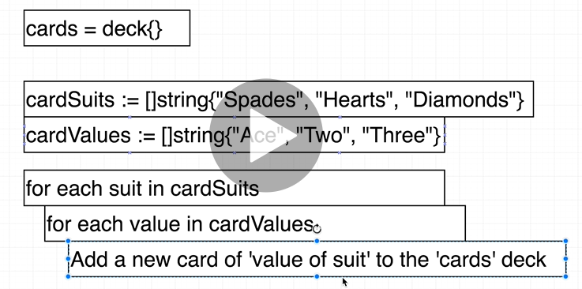

**Note : whenever we have a variable in loop and we don’t want to use it we can replace it with**

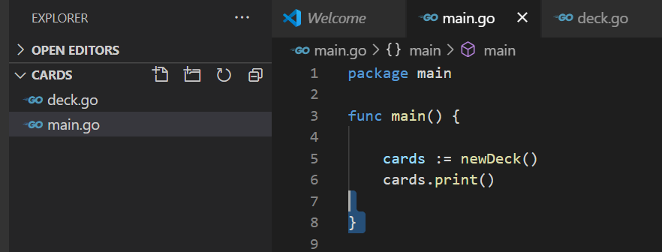

**_**

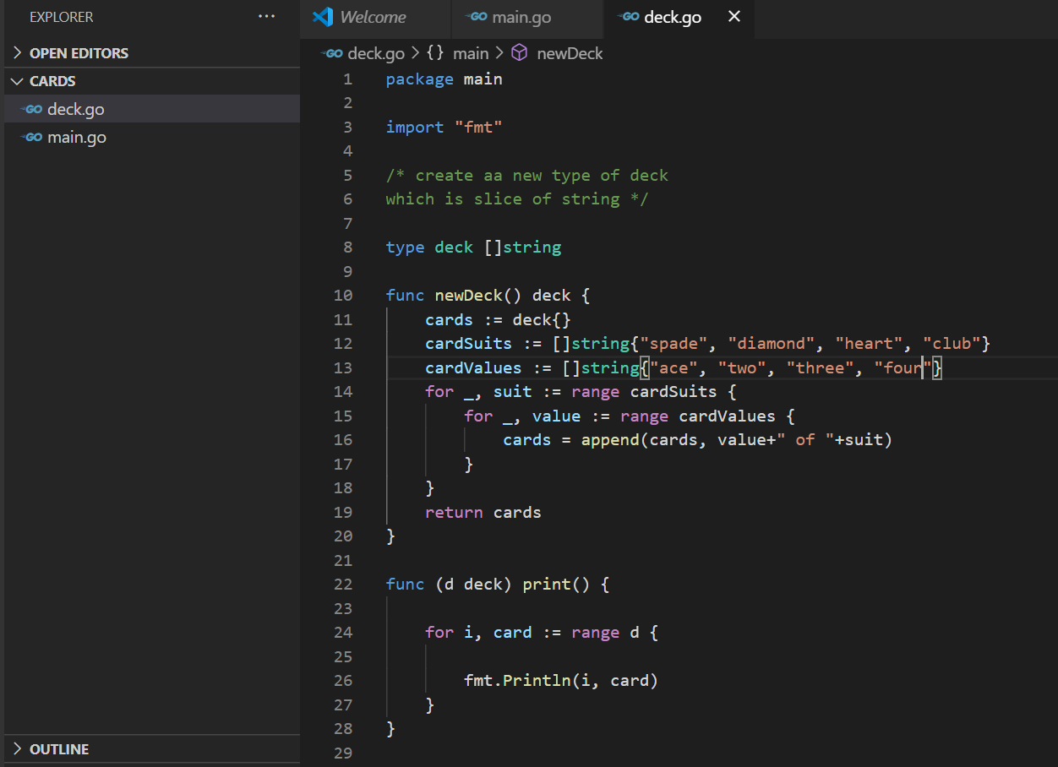

**Output**

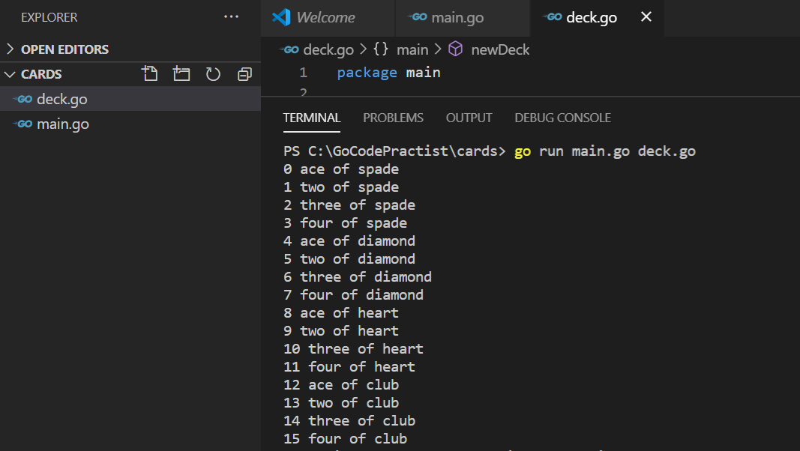

**Slice Range Syntax**

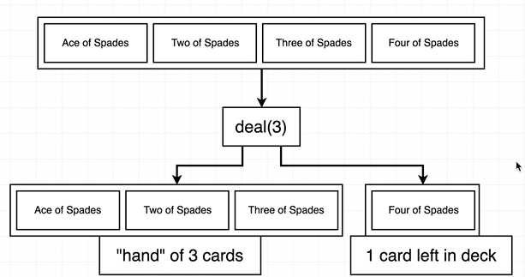

To access slice

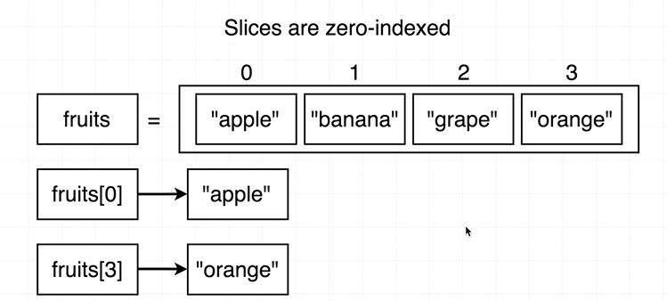

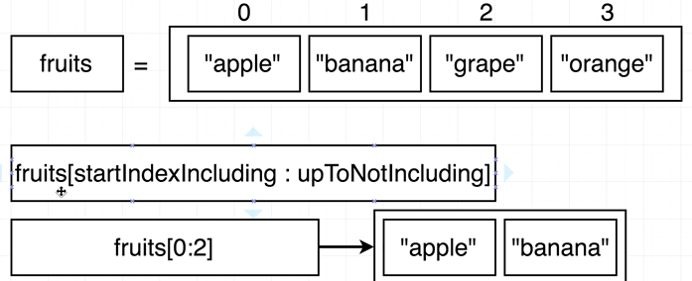

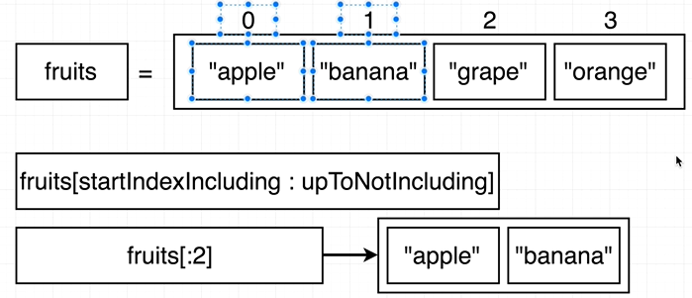

**Need to implement (deal function)**

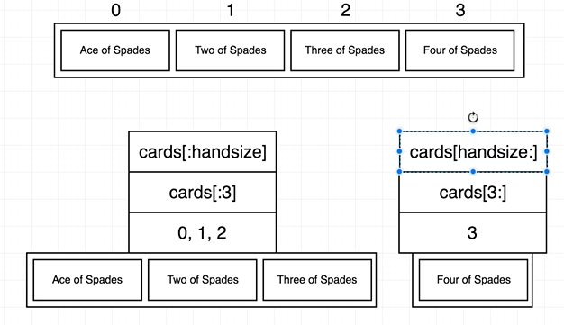

Multiple return values

**Go support to return multiple values from one function**

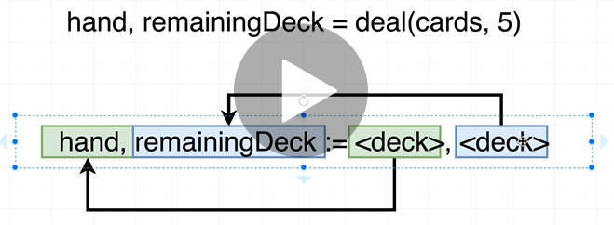

**Example :**

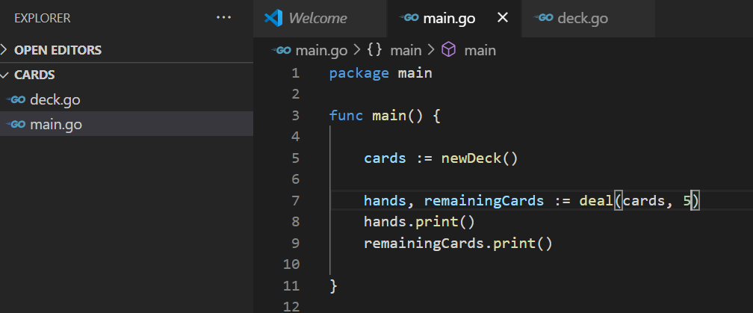

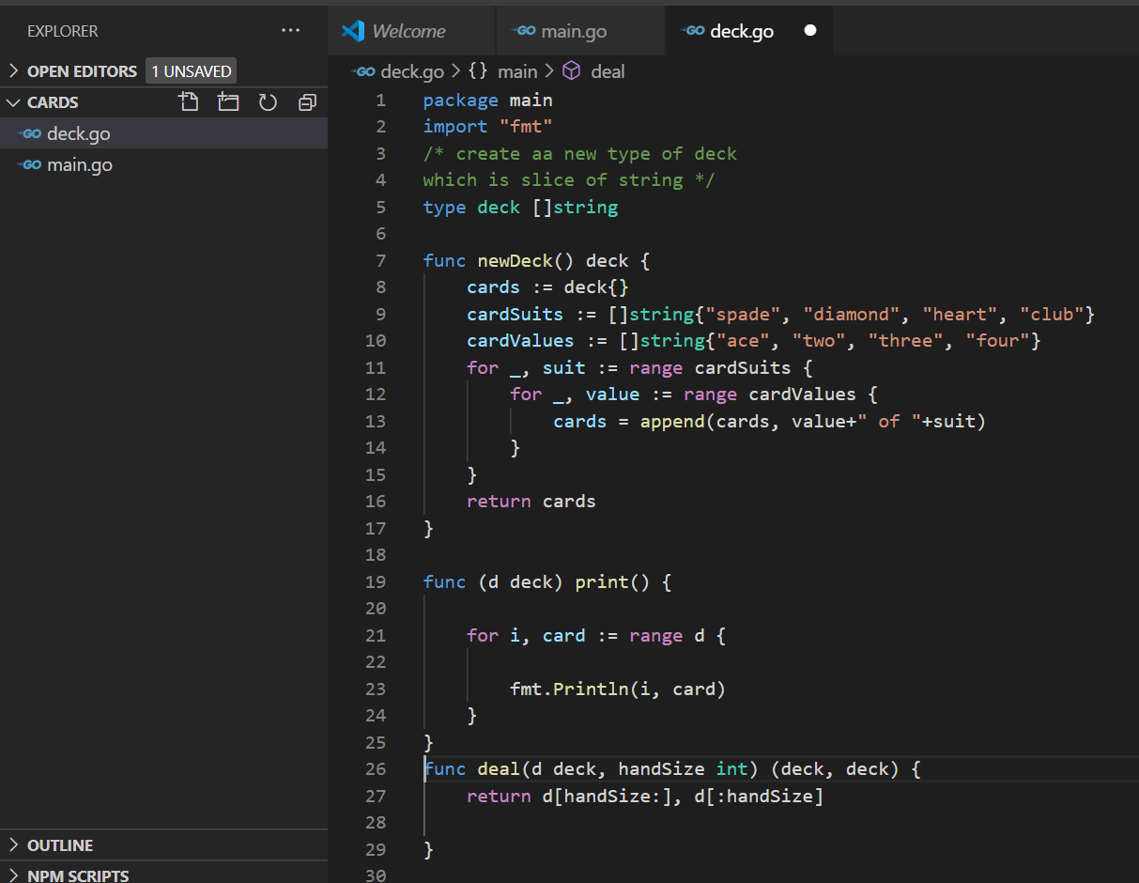

**// output**

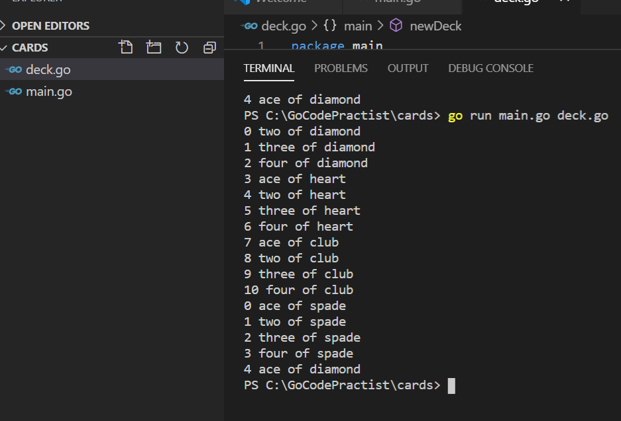

**Byte Slice**

**Requirement : save to file**

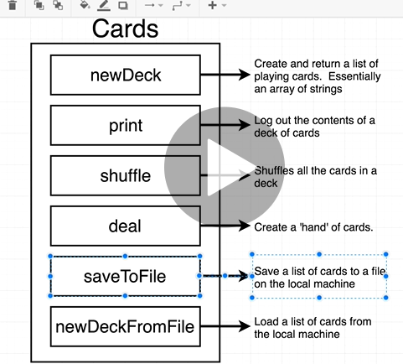

**Golang.org/ioutil/writefile**

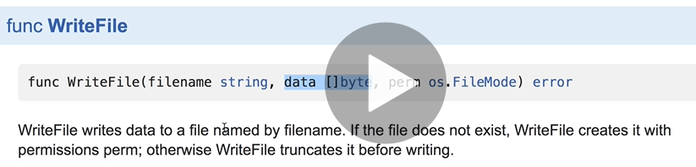

**Note : the only way we can use this function if we pass as a byte slice**

**Byte slice think as string of character( byte slice represent a string)**

**Byte slice : computer friendly representation of string**

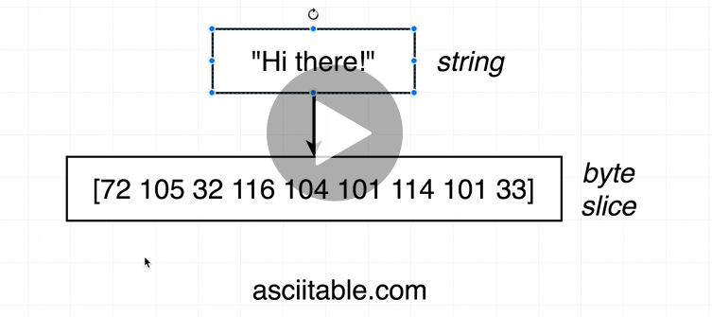

**Deck to string**

**Will use type conversion**

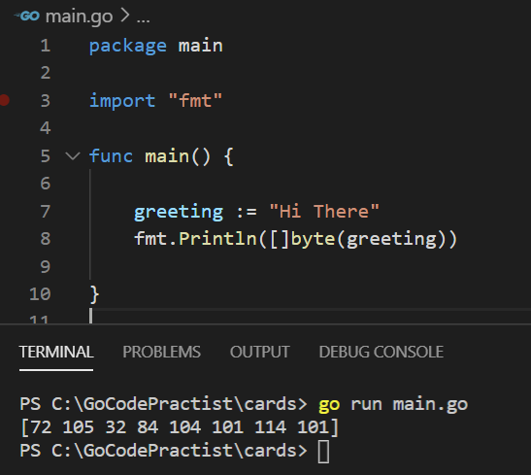

**Question : how to turn deck type into byte slice**

**Process will follow**

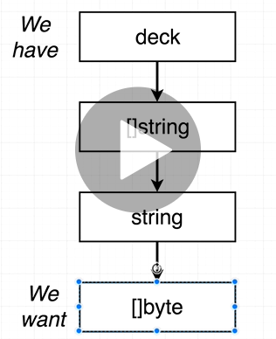

Requirement : write a helper function that takes a deck and return a string

Question :) why sometime use receiver

Joining a slice of string

Convert deck into slice of string then convert slice of string into string

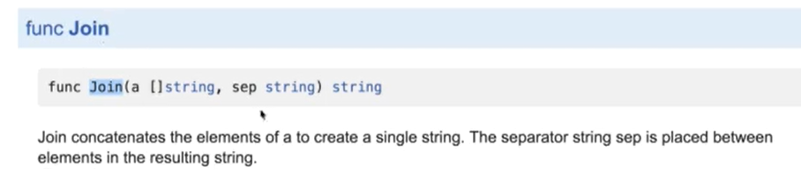

Join will take slice of string and reduce down one single string

<https://golang.org/pkg/strings/#Join>

Example

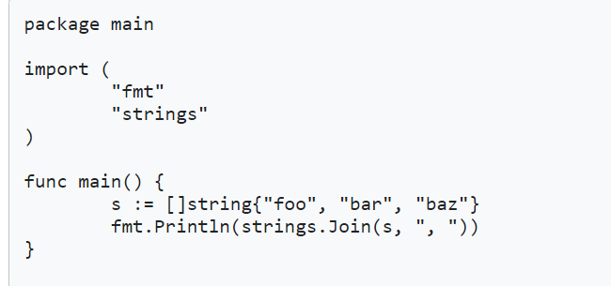

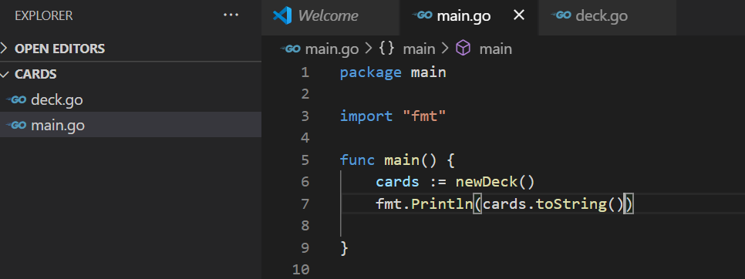

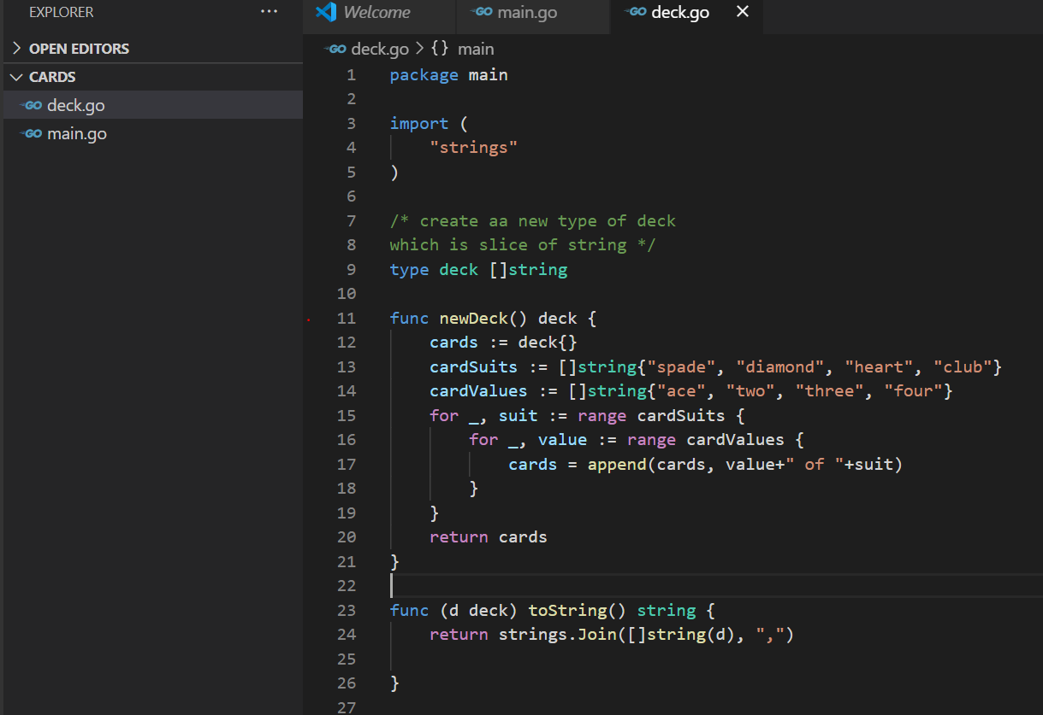

Output

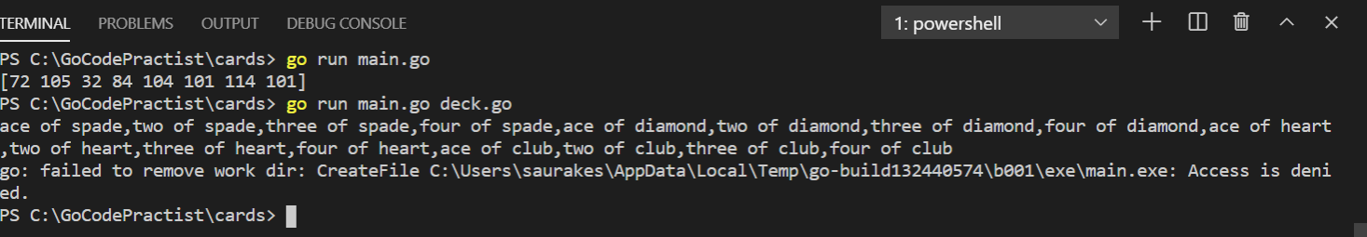

Saving data to the hard drive

0666:- anyone can read and write this file

Note : iotutil package is subpackage of io

**Example:**

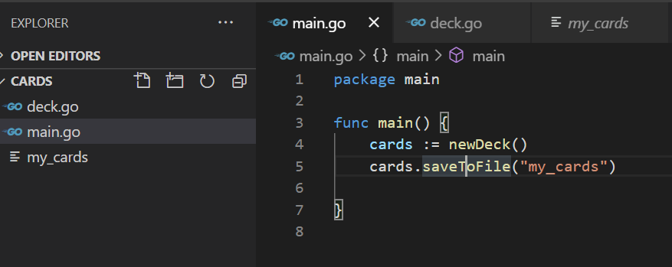

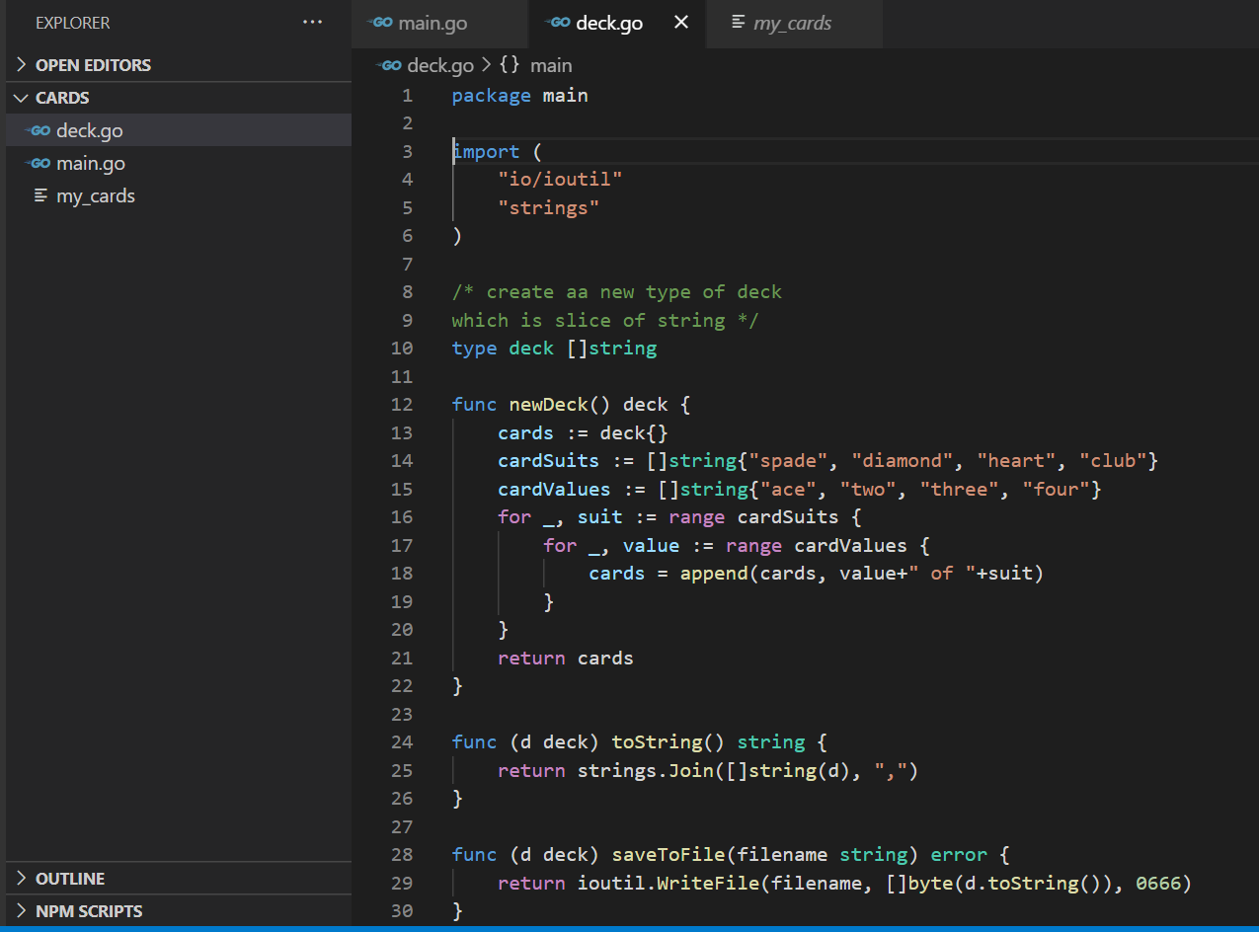

Reading from the hard drive

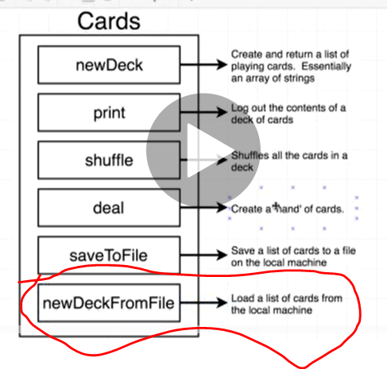

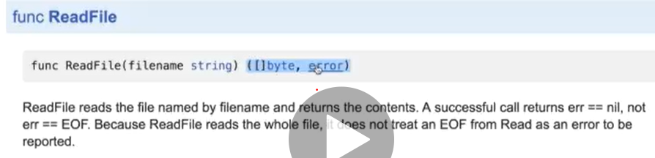

Note :

nil is value in go which essentially means no value

Check the readfile syntax and as per that write the code

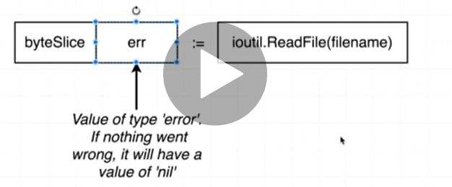

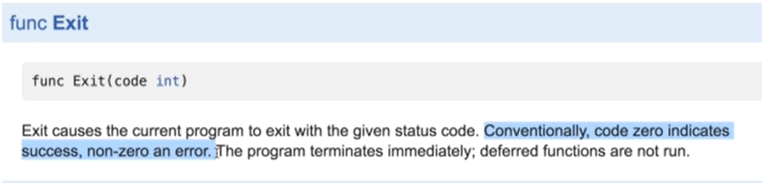

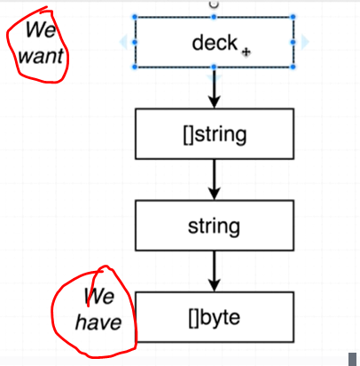

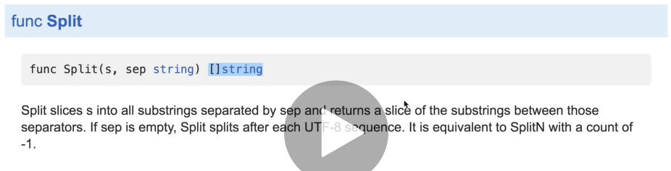

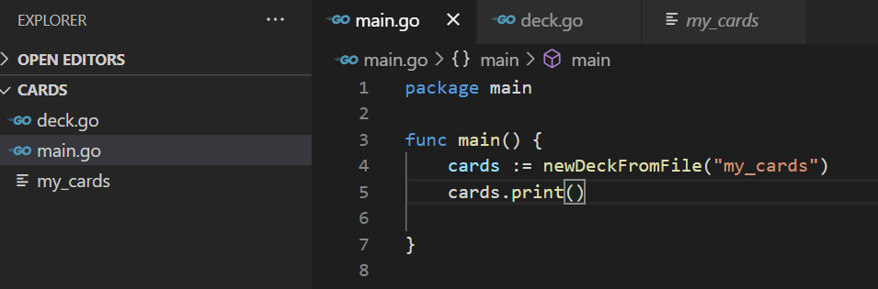

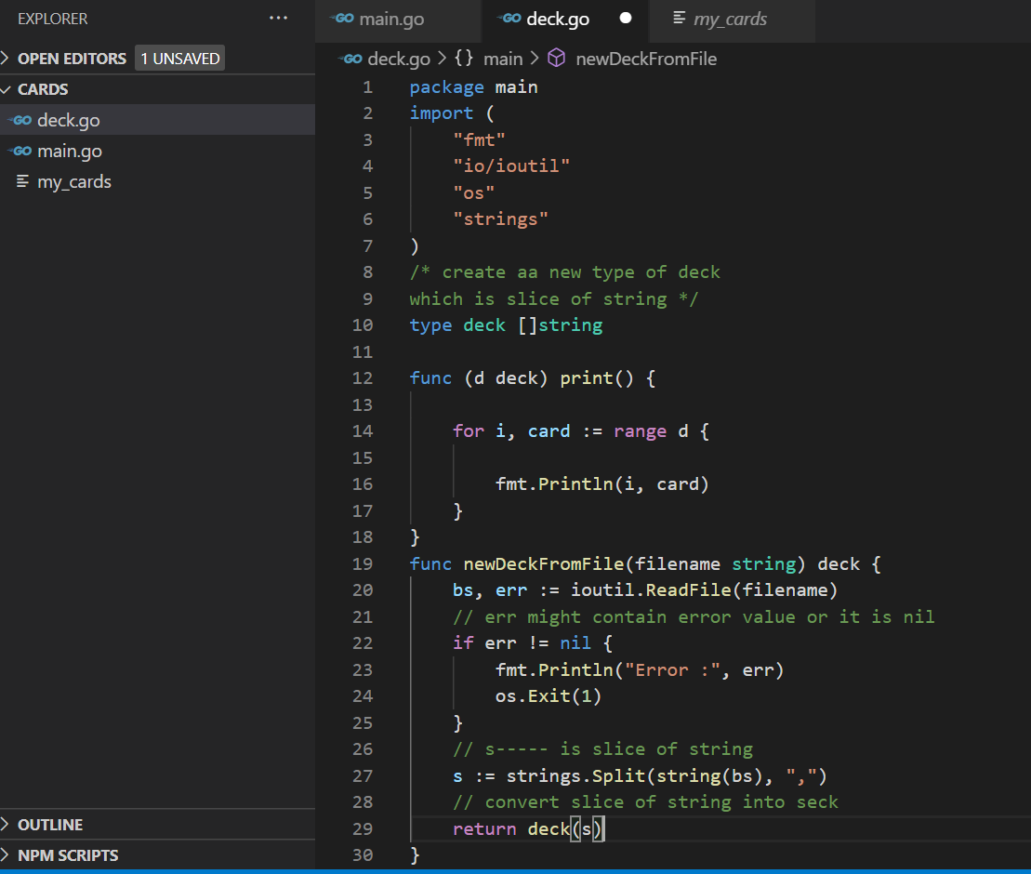

Shuffle a deck

Randomize the order of all deck

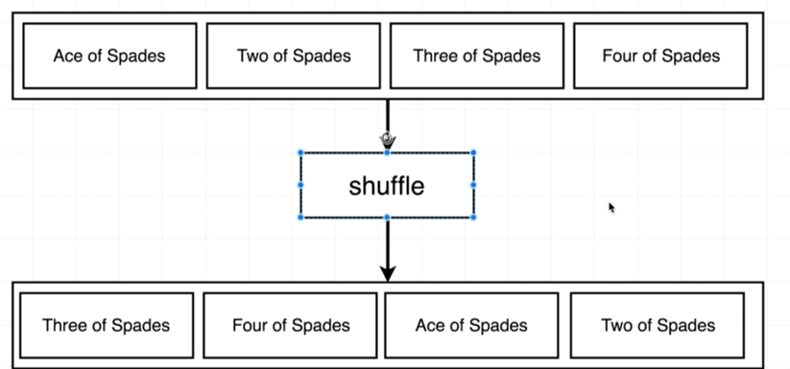

Note :

go standard library does not have any built in function to automatically shuffle a slice or shuffle a array

So we need to put own custom logic to manually shuffle a slice

**Logic to shuffle card**

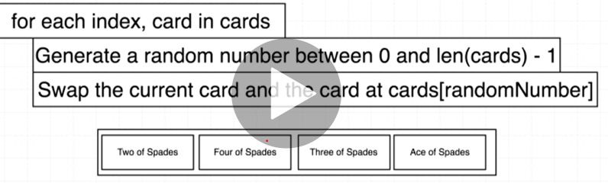

**Challenge : how to generate random number between 0 and length of card**

**Use package : math --subpackage rand/ func Intn**

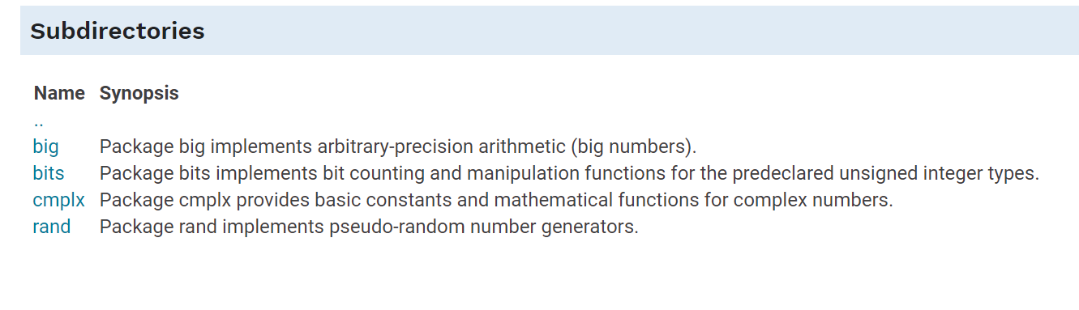

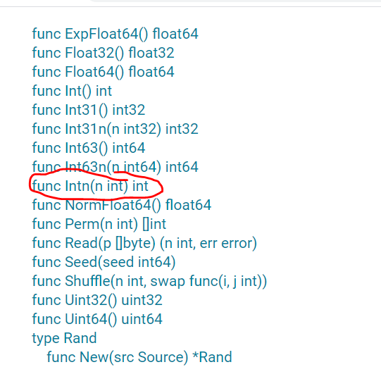

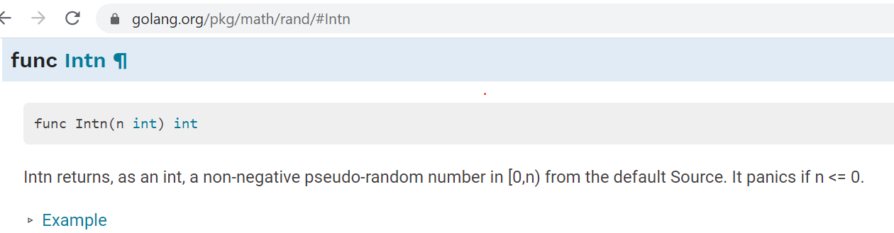

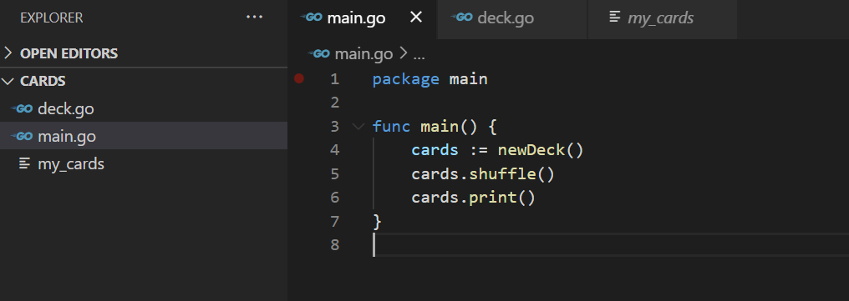

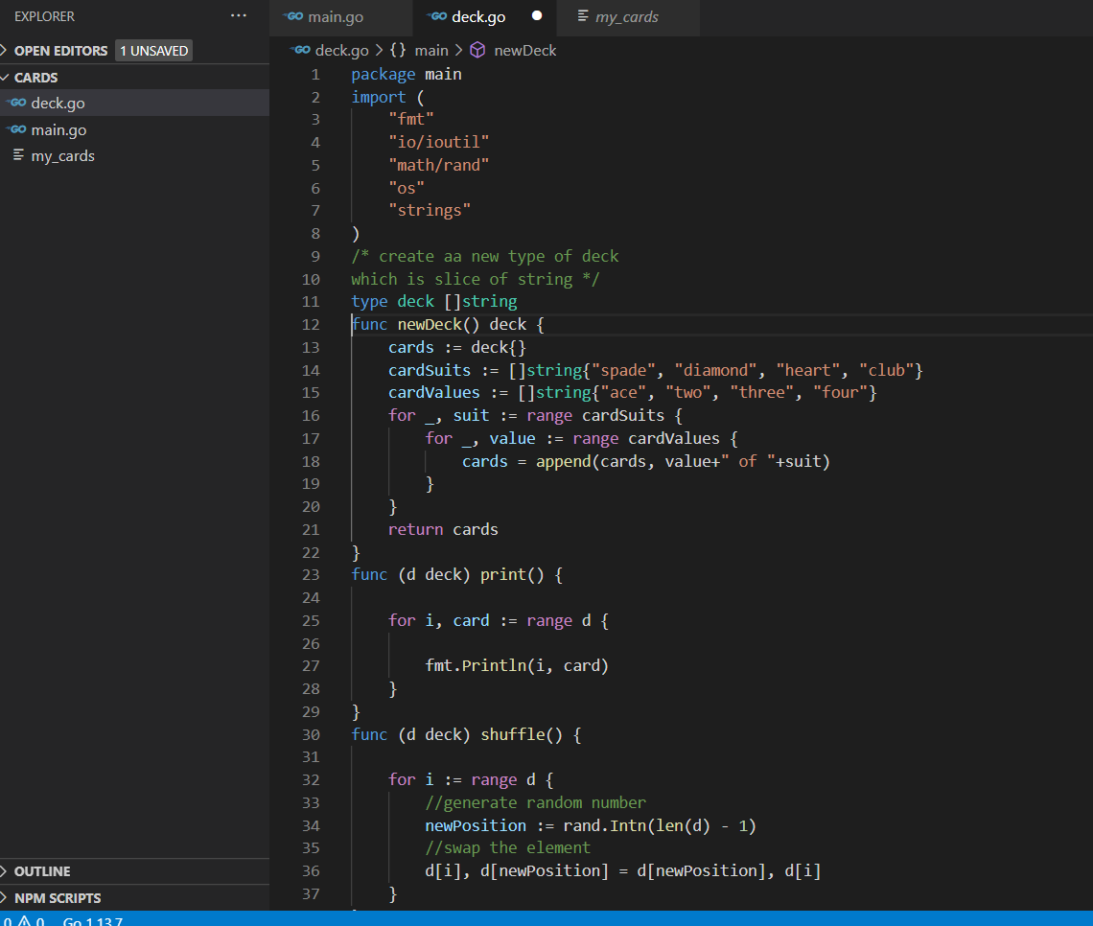

**// output : getting every time same order for last four**

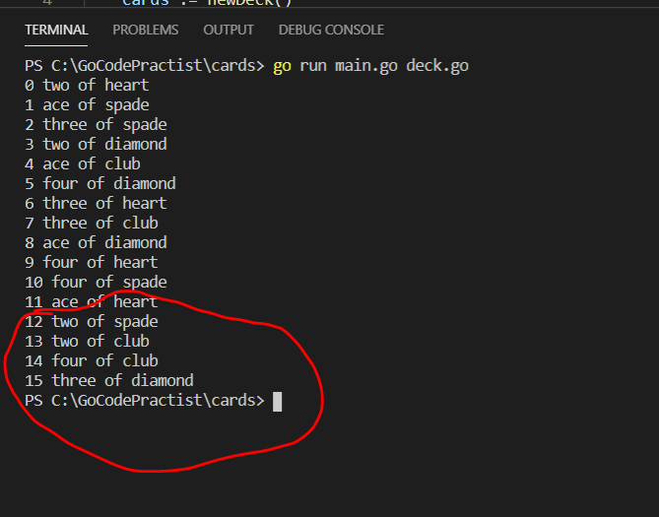

**Random Number Generation**

**Looks like actual logic is not working correctly something went wrong**

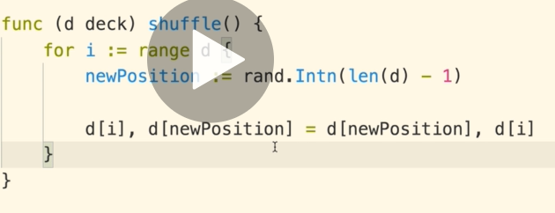

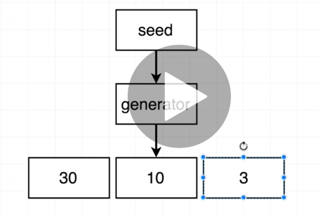

**Seed : source of randomness inside our generator**

**In order to fix this every time we need to generate new seed**

**Note : learn how to navigate standard packages**

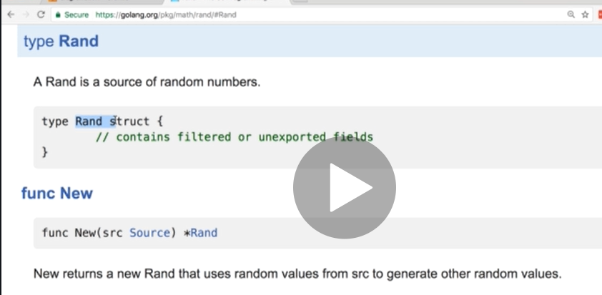

**Requirement :**

**We want to specify seed for random number**

**Source is seed**

**To make a source we call newsource**

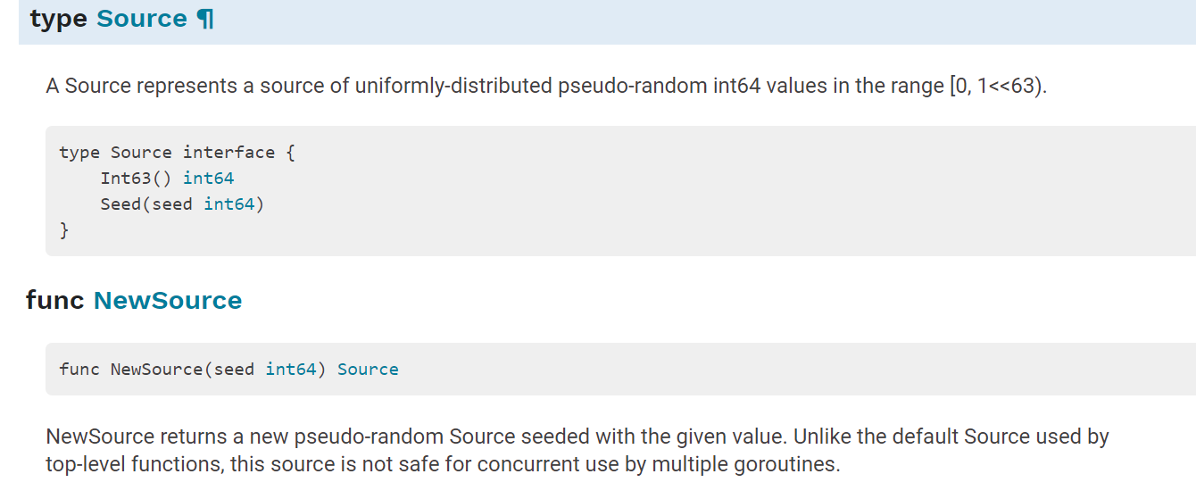

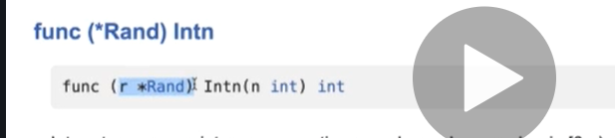

**Means : if we have a value rand r that value can call Intn function**

**// time package / now**

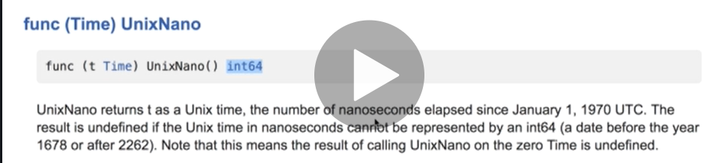

**Int64 we will use as seed value every time we will run it , generate new value**

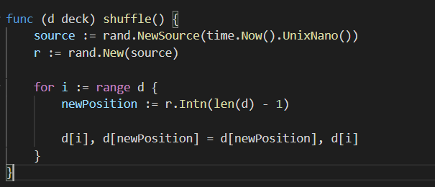

**Testing with Go**

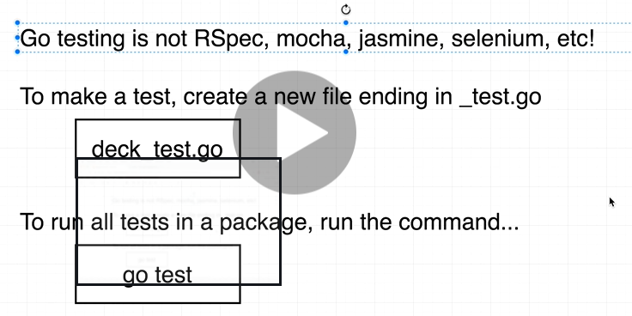

**Writing useful test**

**How to know what we have to test**

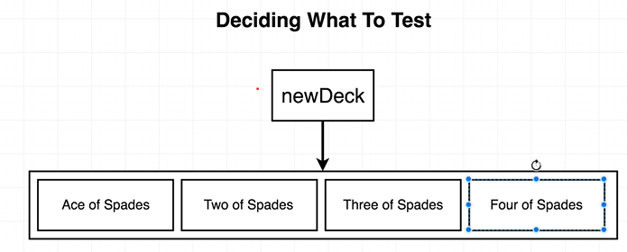

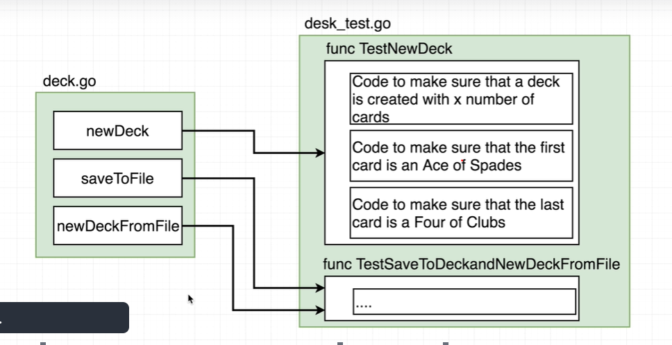

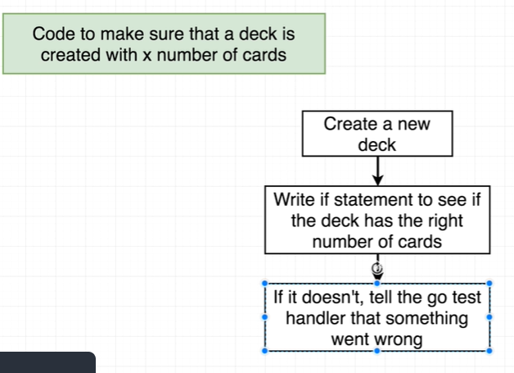

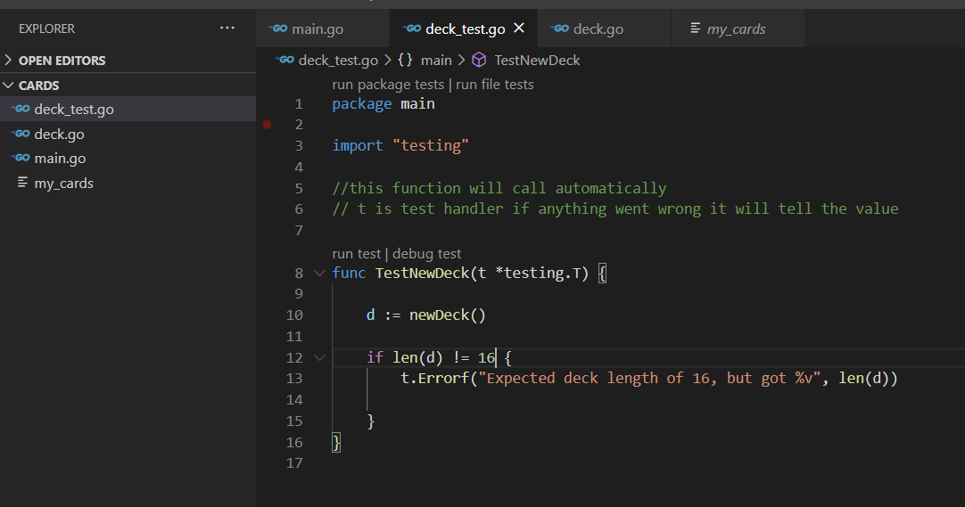

Assertions Element in a slice

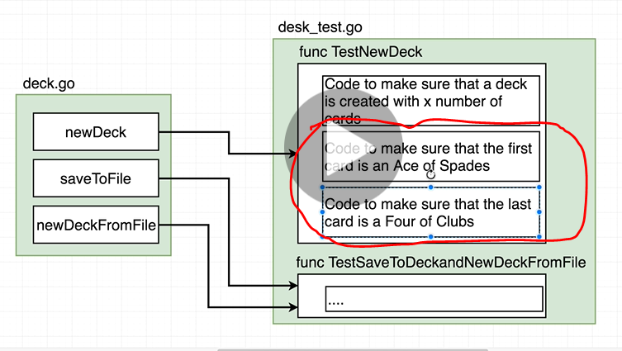

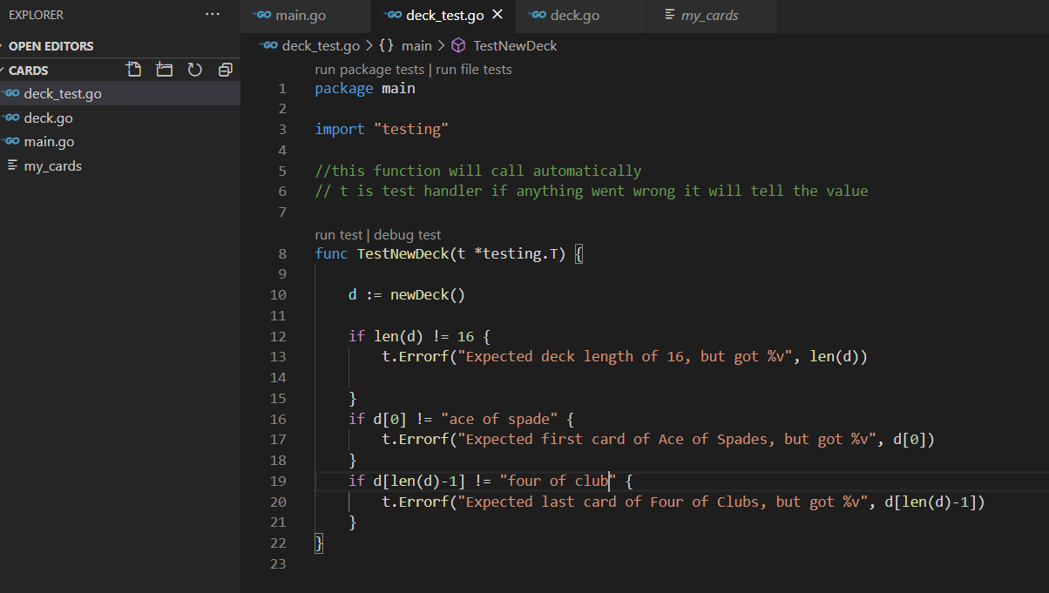

**Testing file IO**

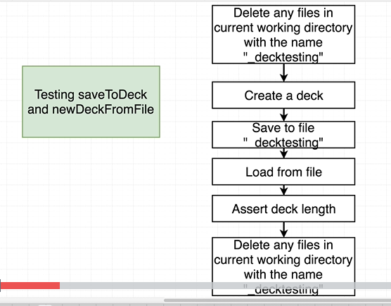

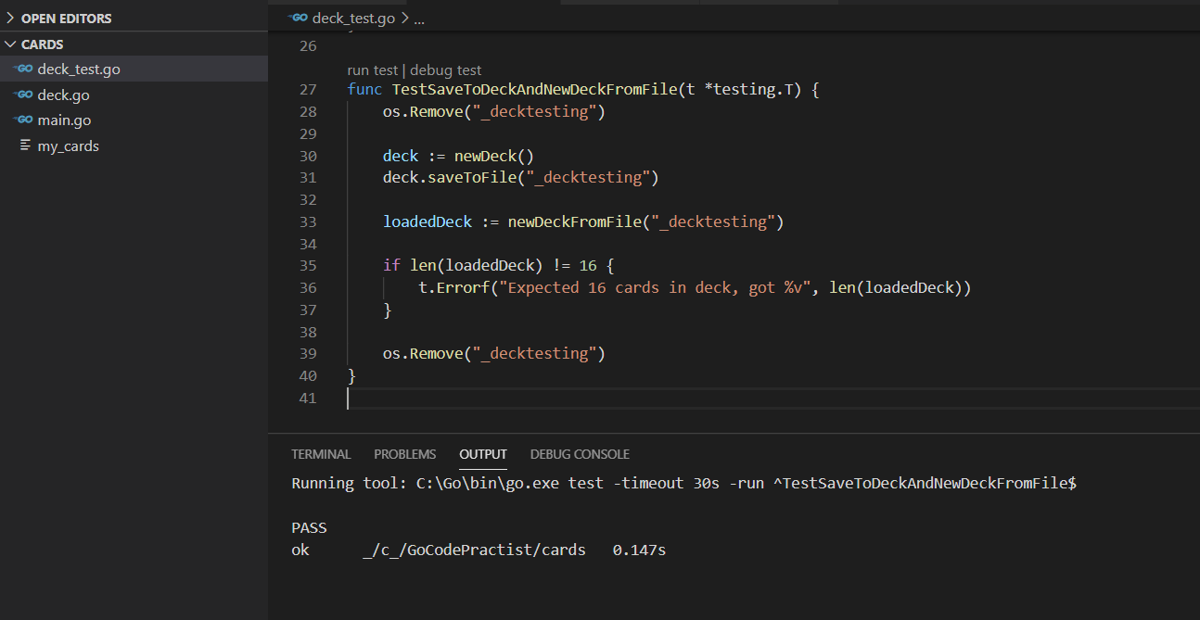

Section 4 :) Organizing data with structs

Defining Structs

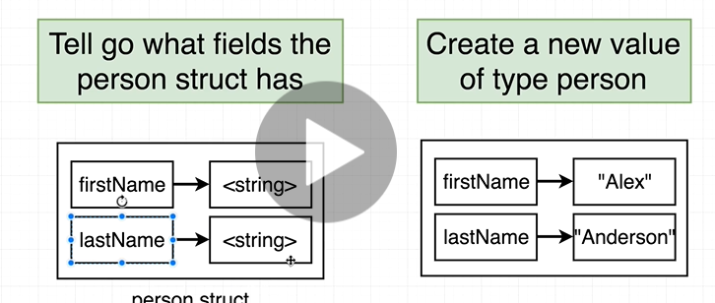

Defining a person and we will give value of person inside function

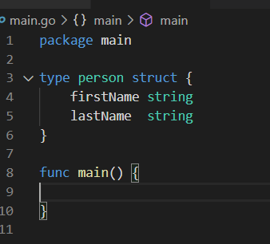

Declaring Structs

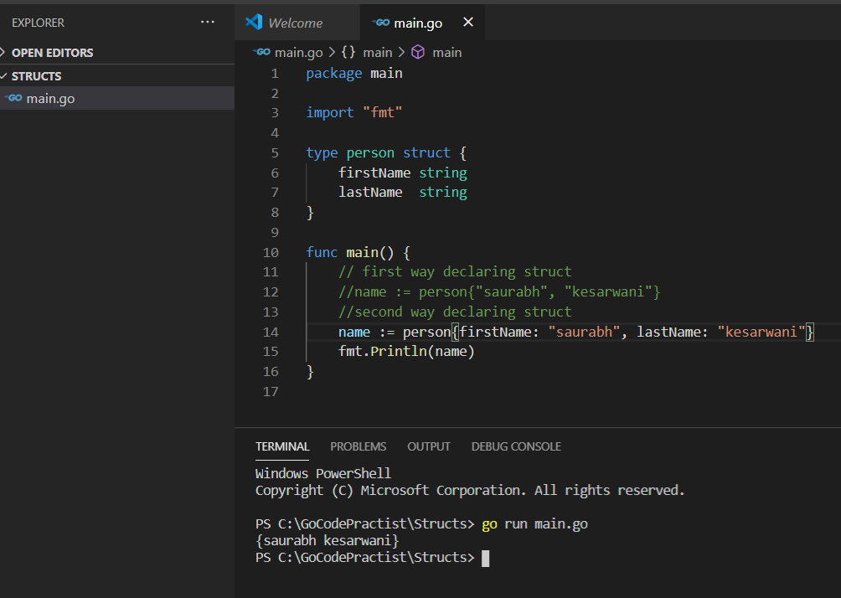

Updating structs value

Third way of defining structs

Note : if we didn’t define any value by default value will be zero

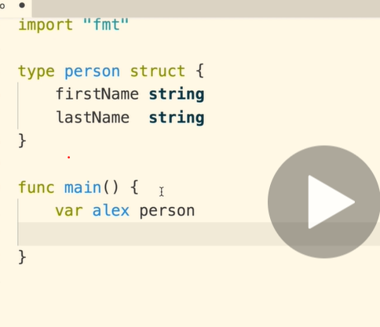

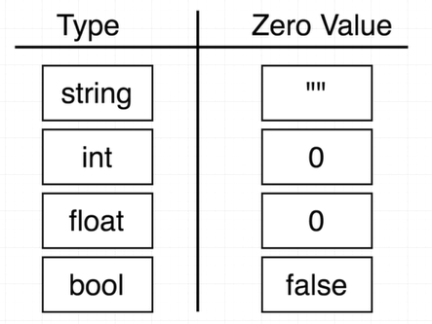

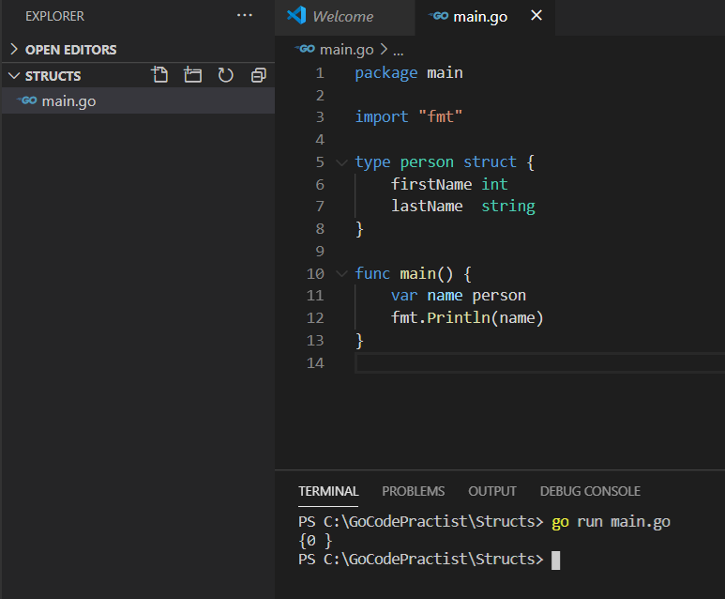

Here firstname and lastname both are defined but values are 0 and empty string

%+v :------will print all the values in name

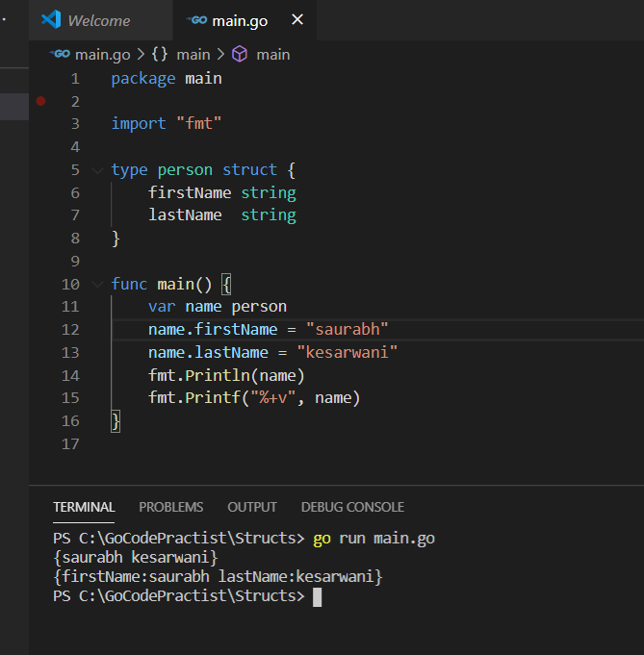

Embedding structs

Define One struct inside another

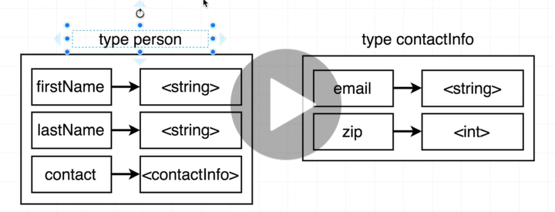

Note : in declaring we don’t need to use comma but in assigning value we need to use comma

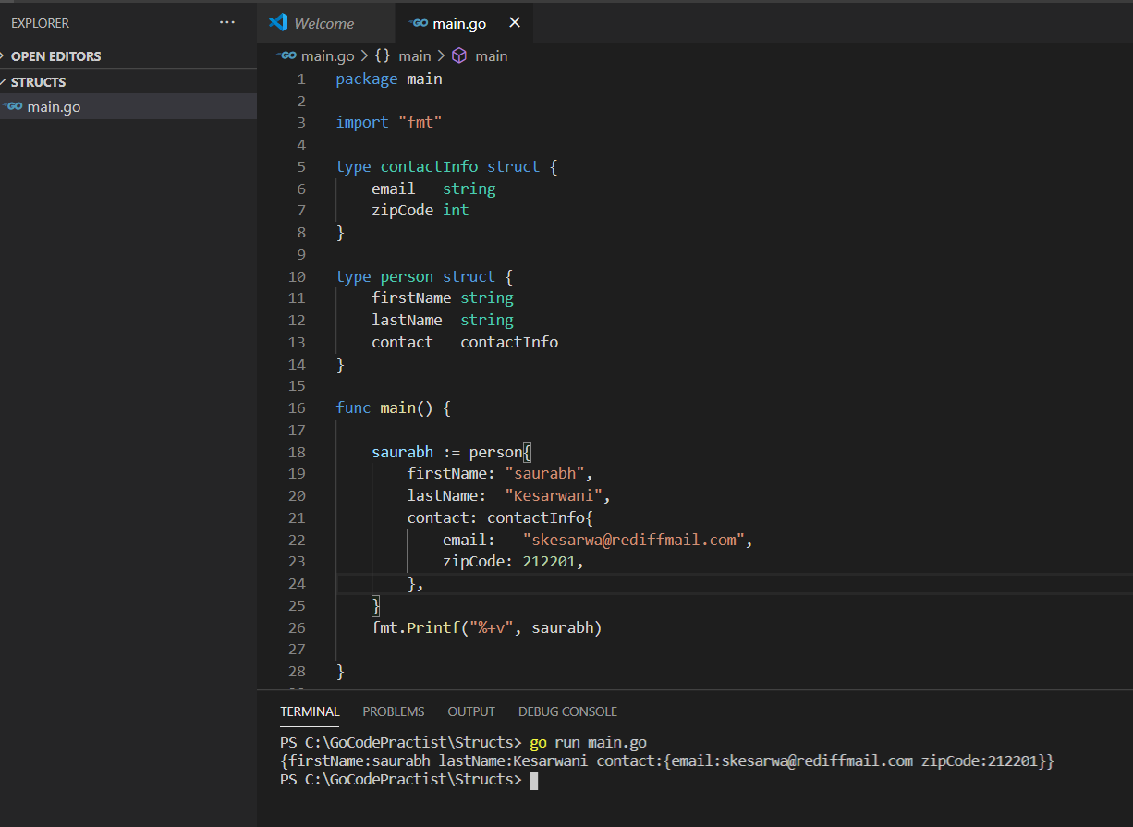

Structs with receiver function

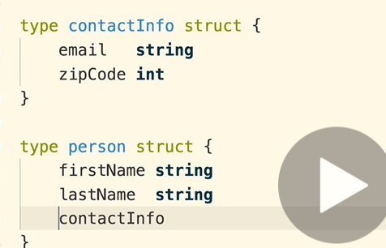

Equivalent to above one

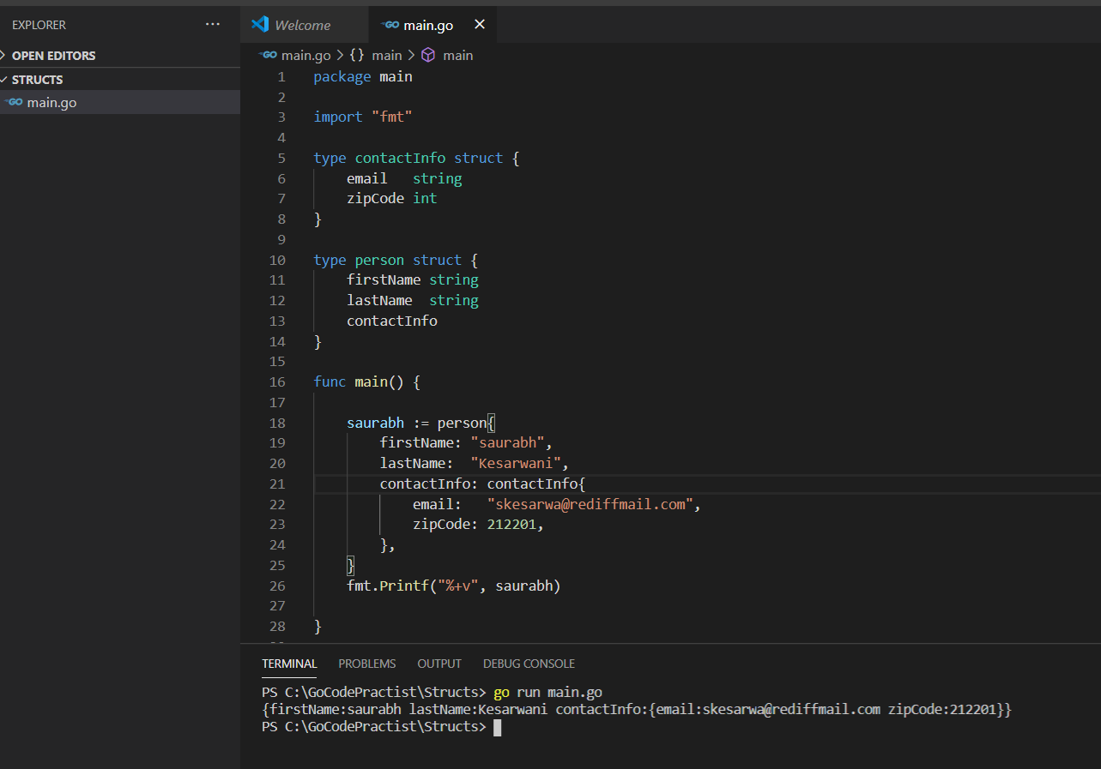

**Write a function updateName that will take person as receiver and update the name**

**Note :** trying to update the name but update not happened

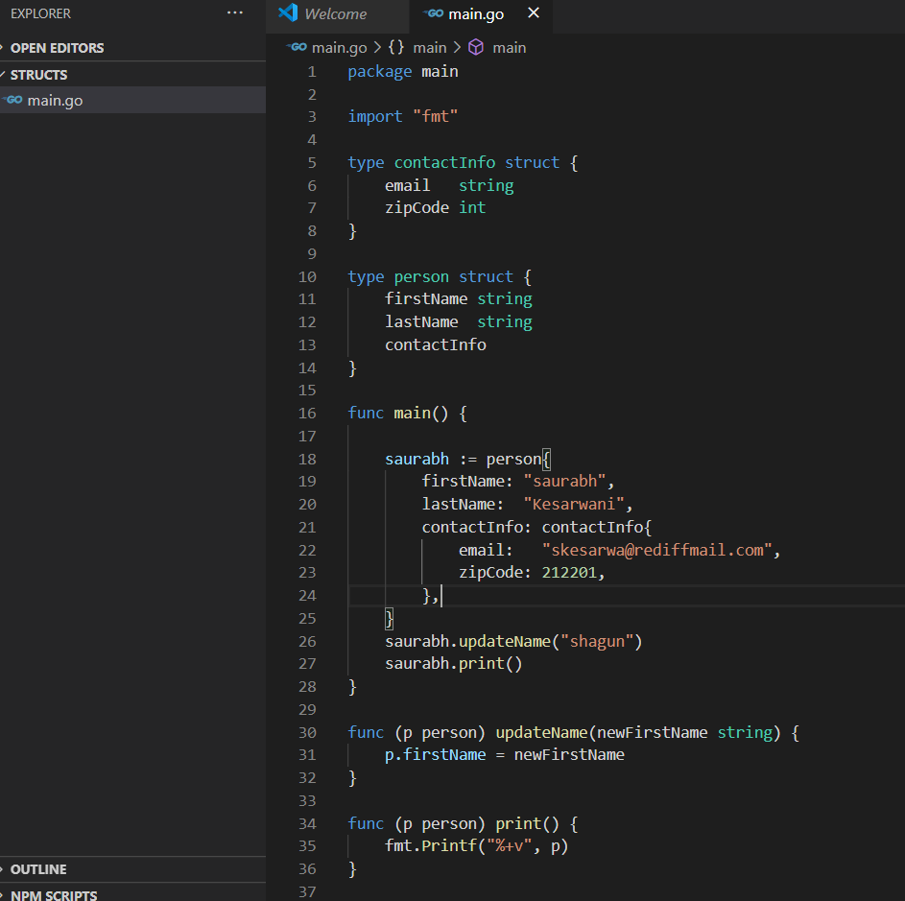

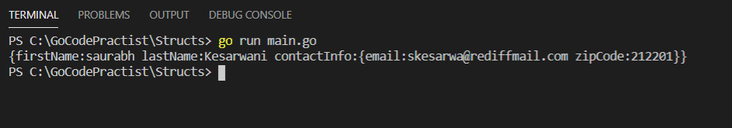

**Pass by value**

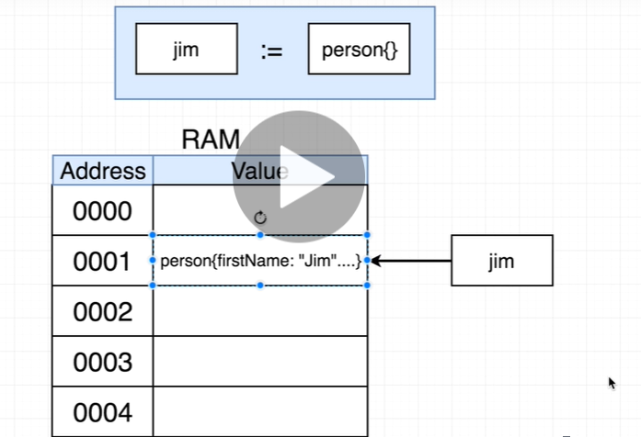

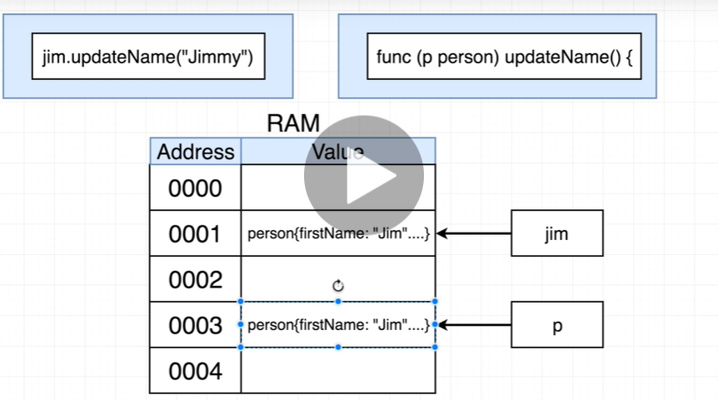

**Note : we are modifying it copy and not the original one**

**Whenever we pass name go make copy of struct and pass it into receiver function so it not effect original struct**

**Requirement : how to rectify this problem**

**Structs with pointers**

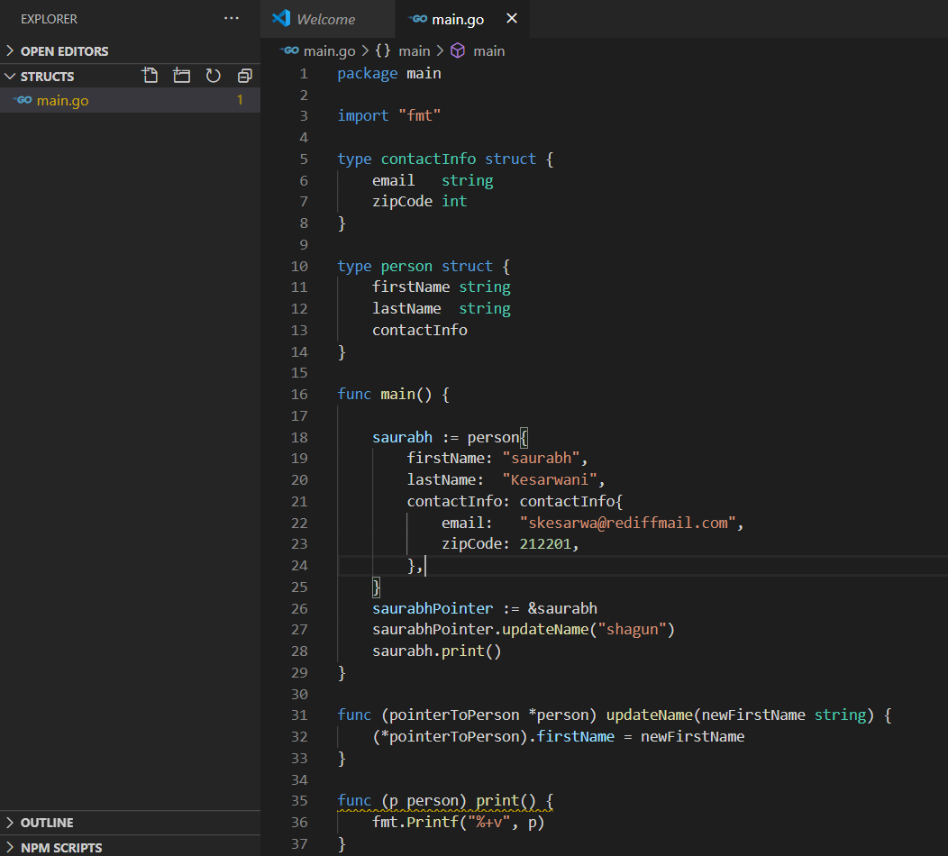

**SaurabhPointer and pointerToPerson both are same**

**// output**

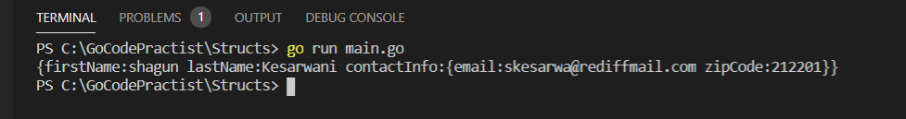

**Pointer Operation**

**Imp**

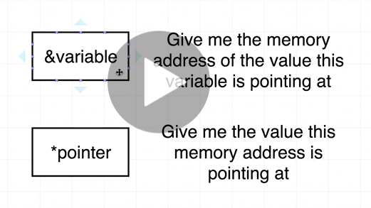

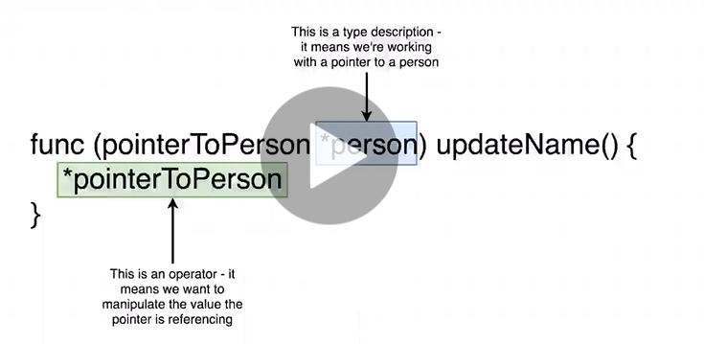

**Imp:**

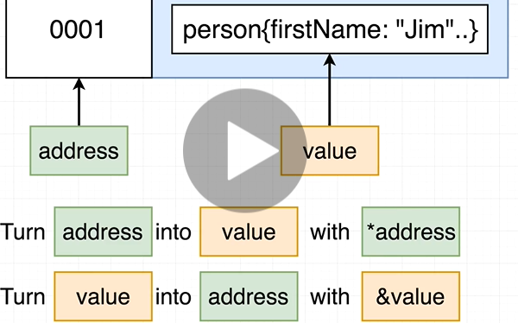

**Pointer Shortcut**

**Very imp Go will allow person to pointerToPerson**

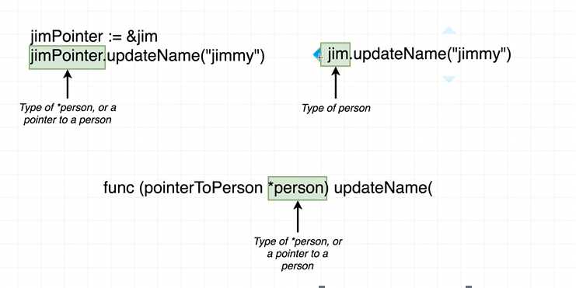

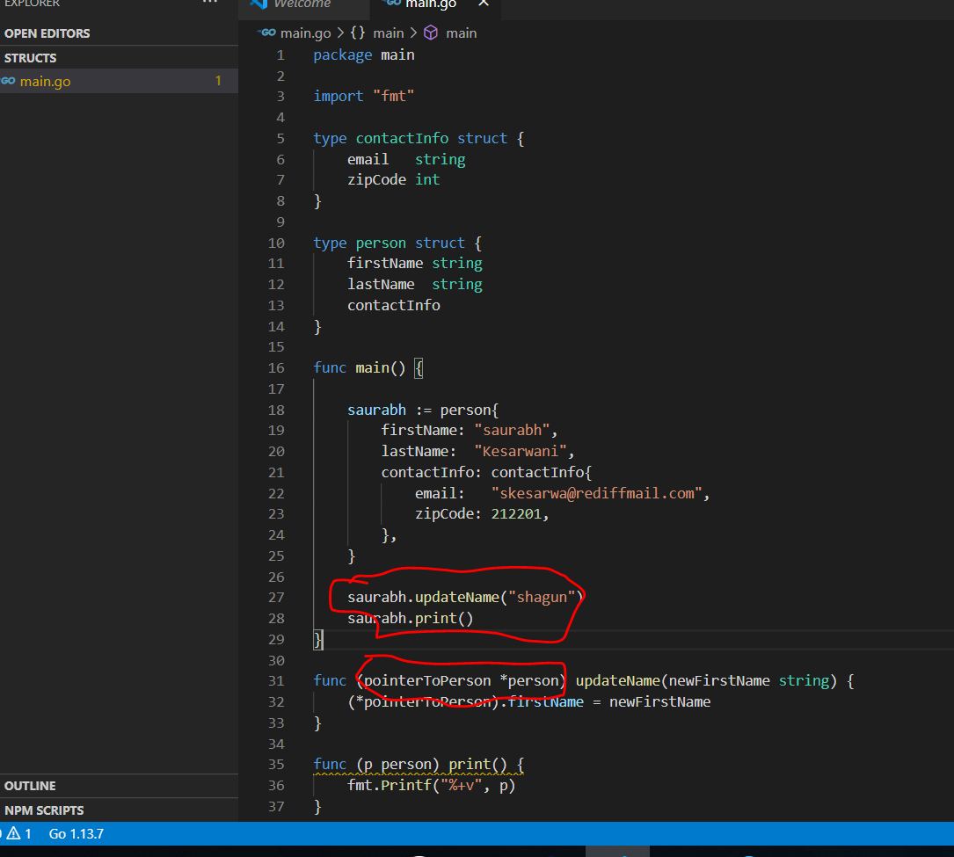

**// output will same as above**

**Gochas with pointers**

**Note:**

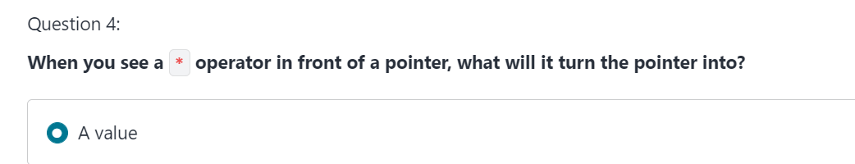

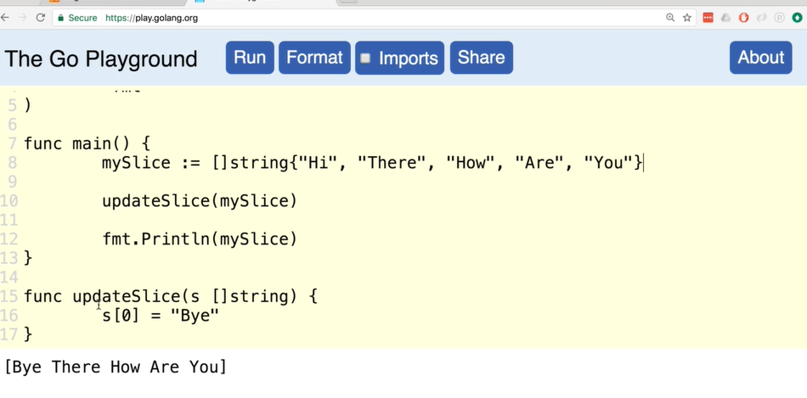

**Reference vs value type**

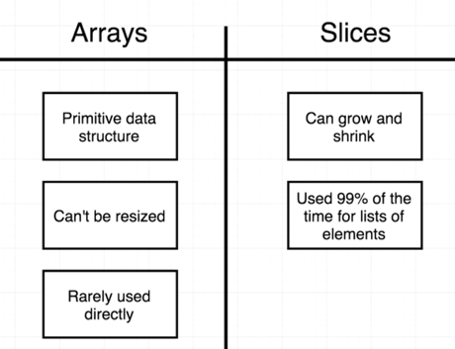

**Slice internally make two data structure**

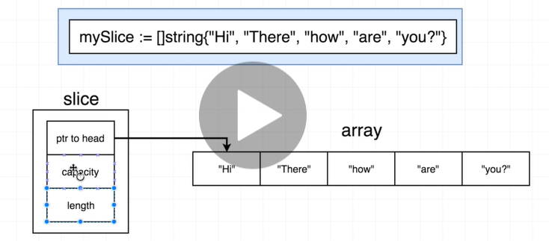

**In go**

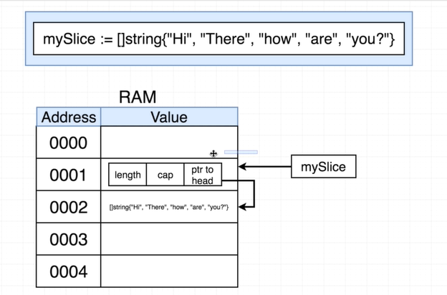

**mySlice return** actually slice data structure not underlying array

Note : **while passing slice to function it still pointing to original array**

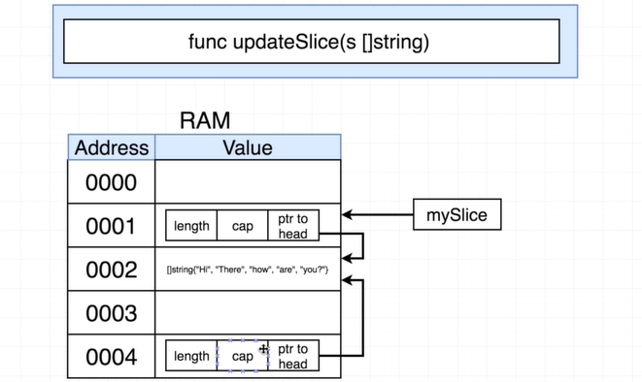

**Note : slice data structure behaves as reference type**

**Very important:--**

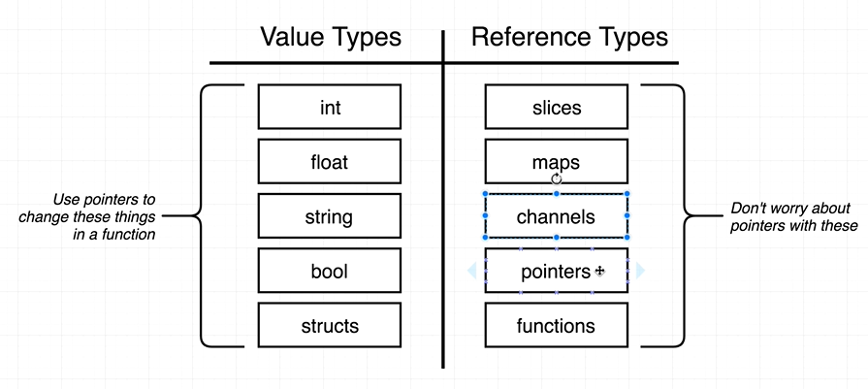

Section 5:) Maps

**Whats a map**

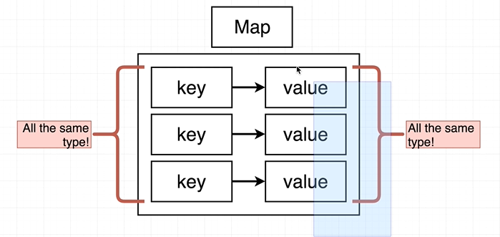

**More than one way to declare a map**

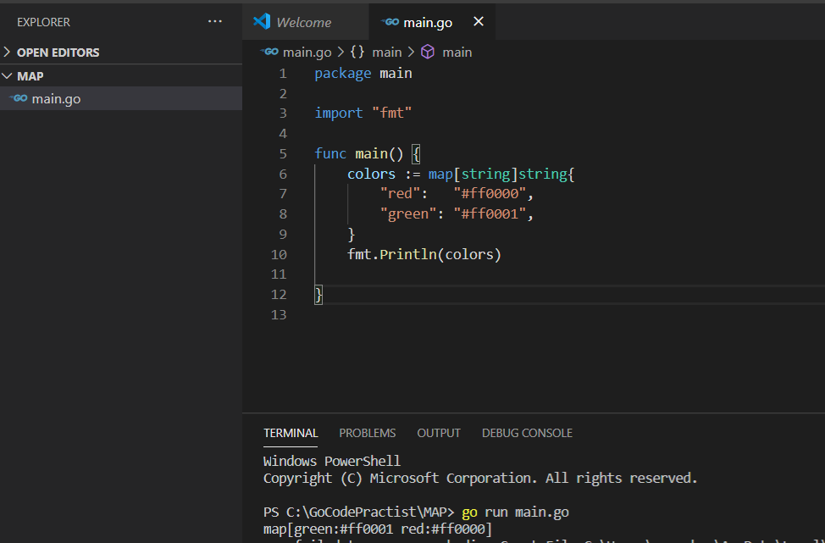

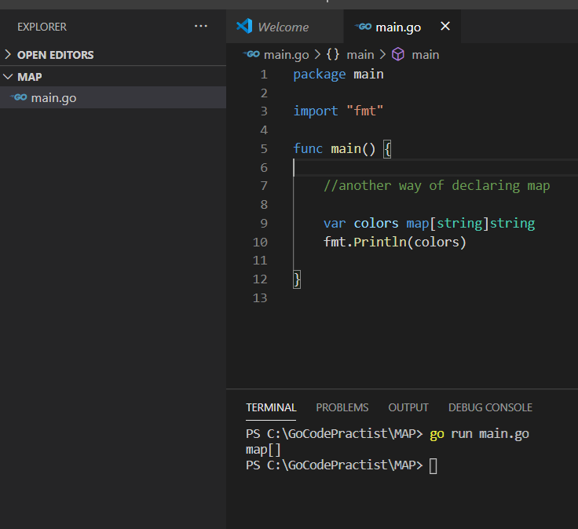

**Note : while declaring a map we will use square bracket**

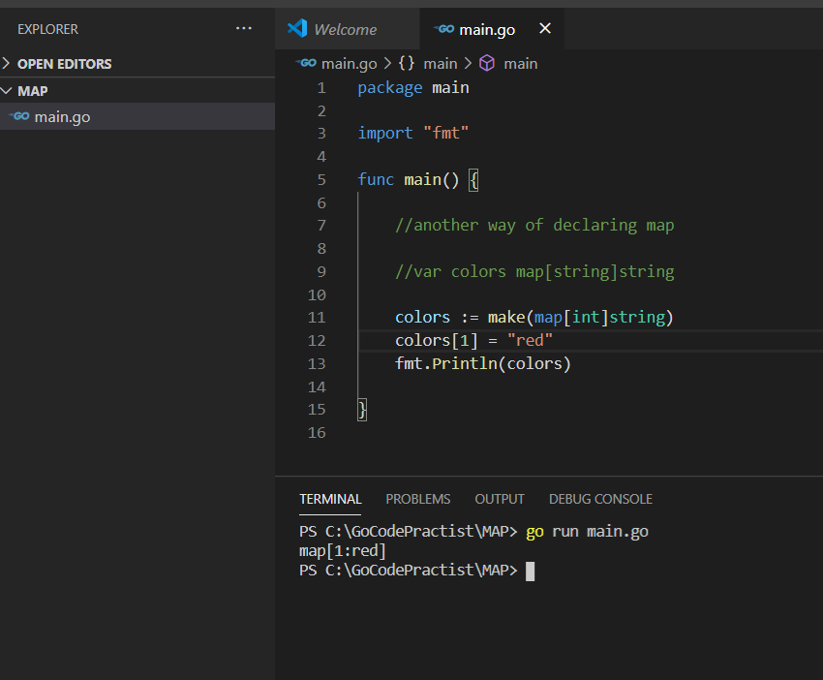

**For delete : use delete(map,key)**

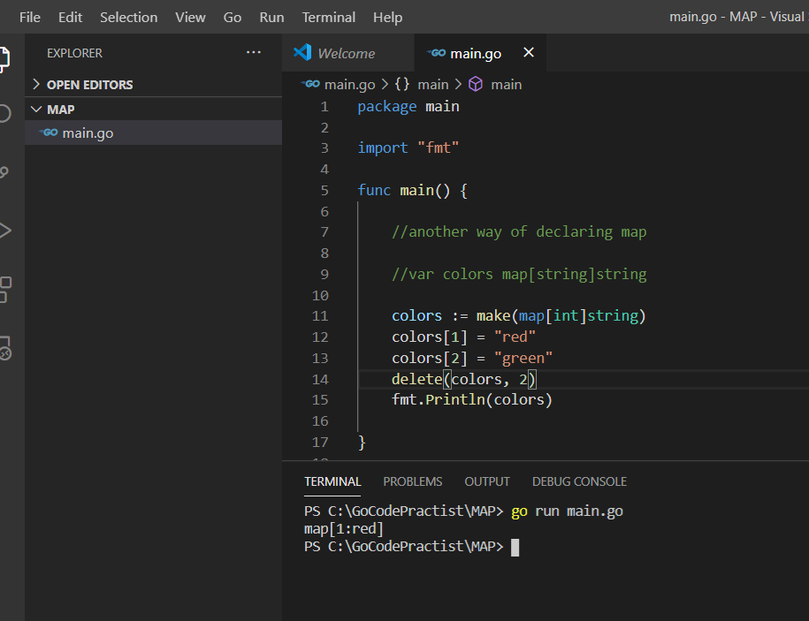

**Iterating over maps**

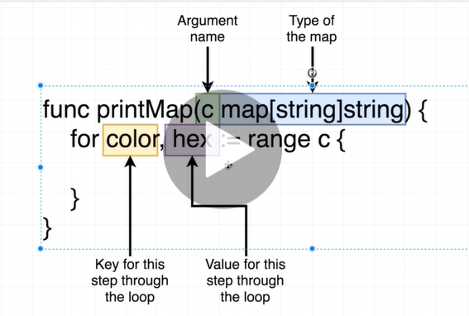

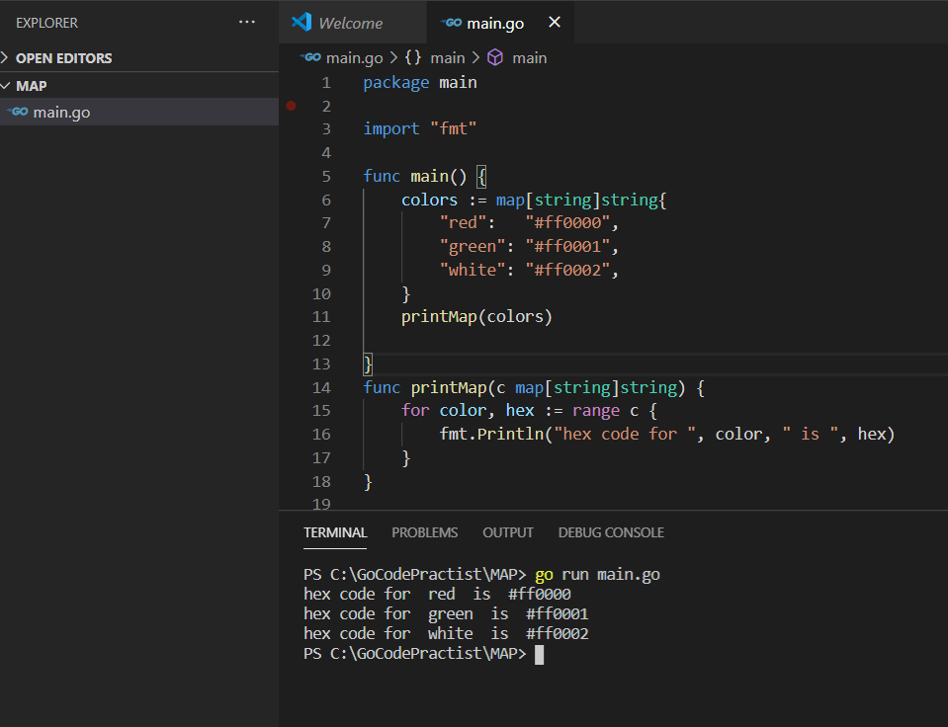

**Difference between Map and structs**

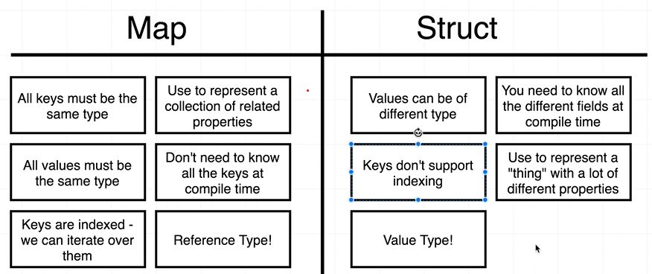

**Note :** for structs we need to define all different value at compile time only.

We cant add it latter

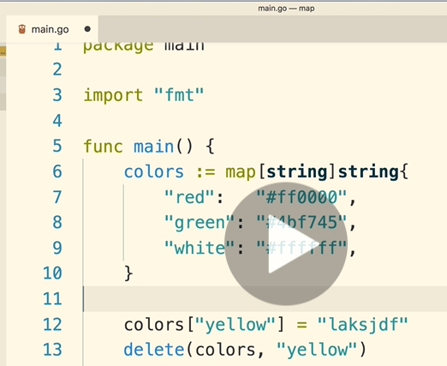

**Section 6 :) Maps**

**Purpose of interface**

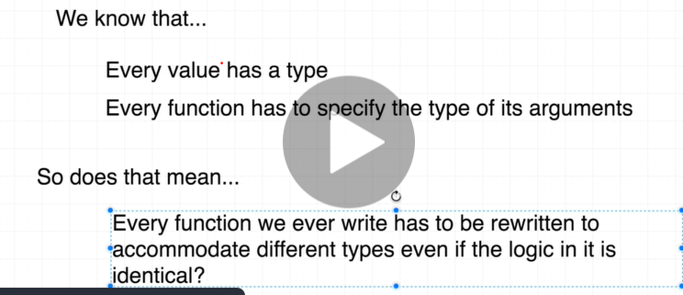

**Note : Interface will help to reuse of code**

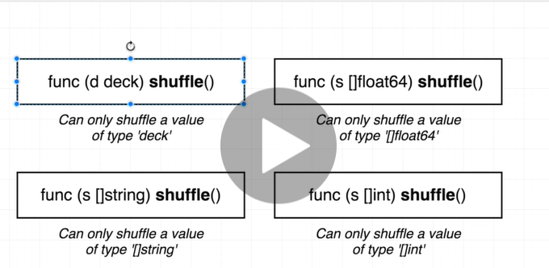

**Sample program :** first write bad way then use interface to refactor it

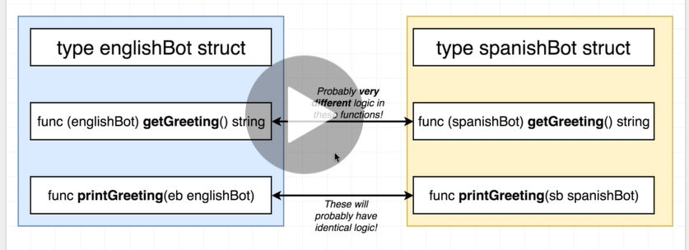

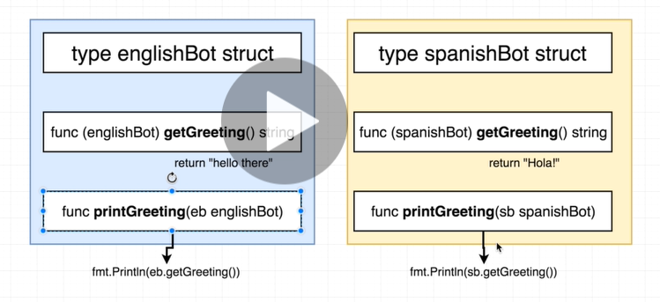

Problems without Interface

Do coding of above

Note : if we not using receiver type we can remove it both are equivalent

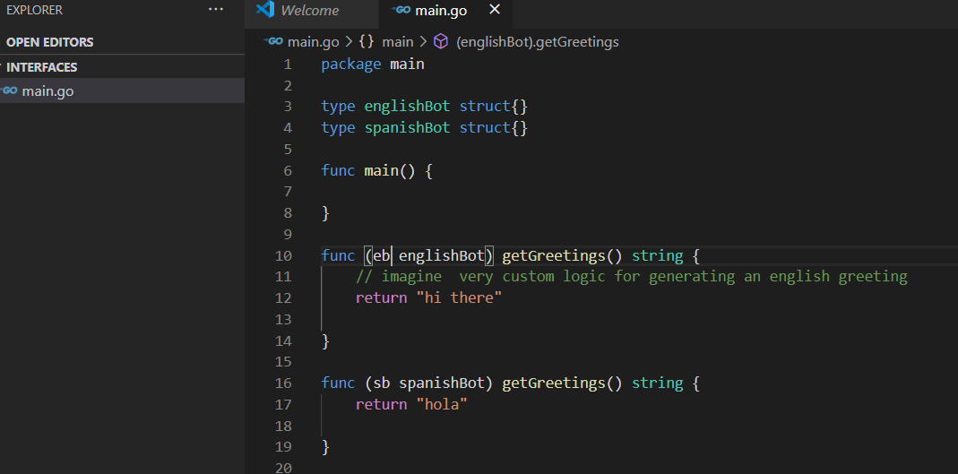

Both are equivalent

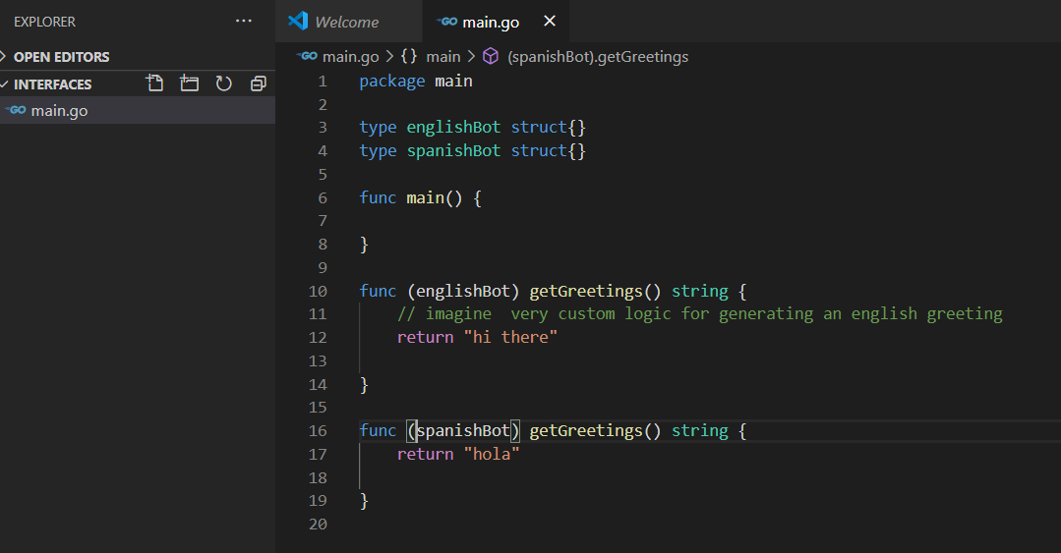

**Function overloading is not supported in golang**

**Interfaces in practice**

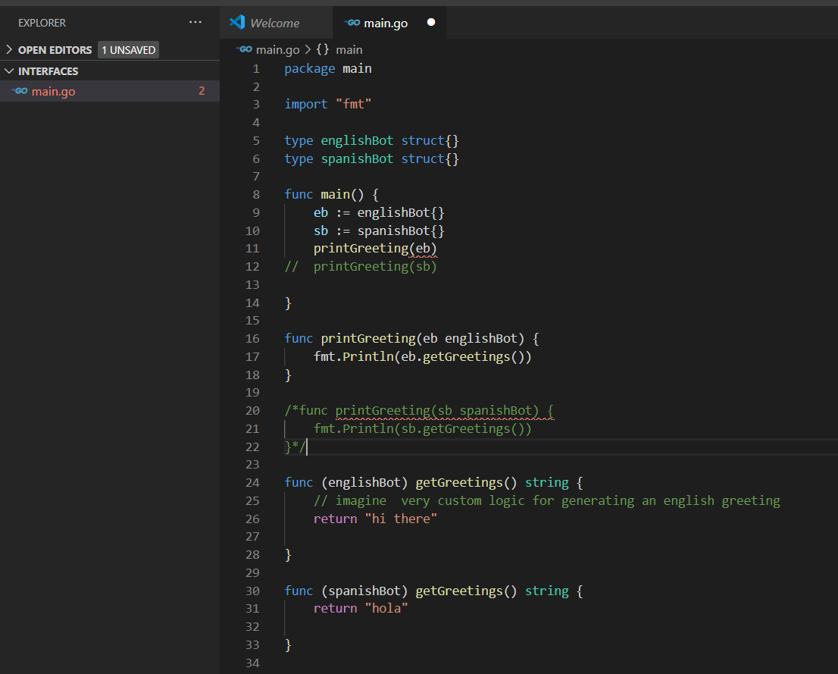

**Need to refactor code : reduce printGreeting function only once**

**Refactored code**

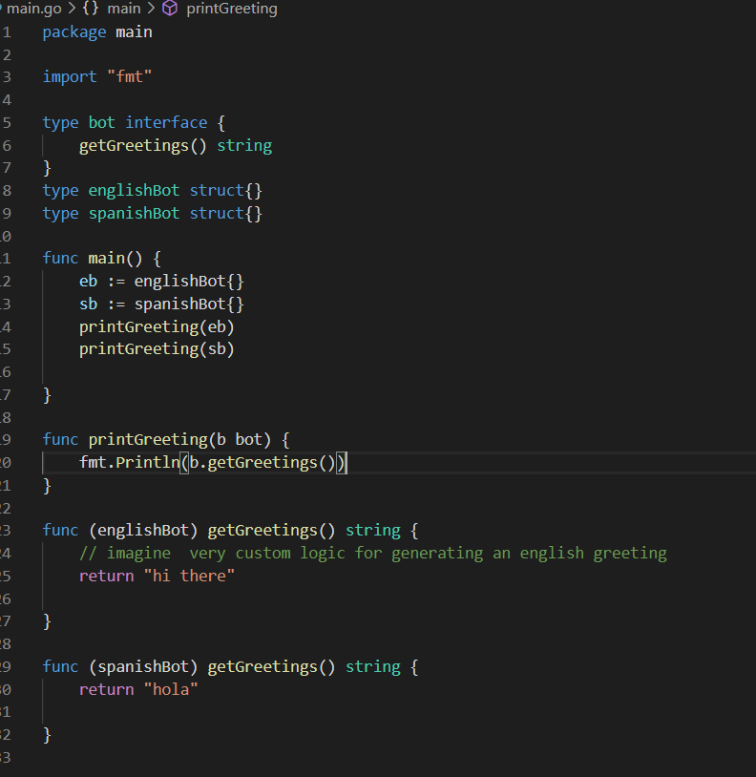

**Anything matches of type interface is of bot type:**

**That’s why we can pass eb to printGreeting method**

**Rules of interfaces**

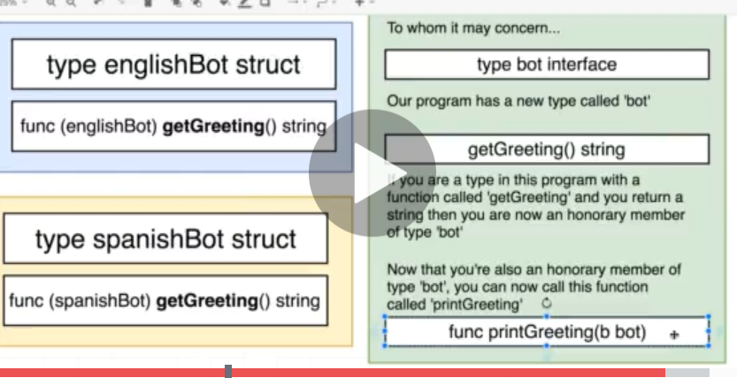

**Another way of representing diagram**

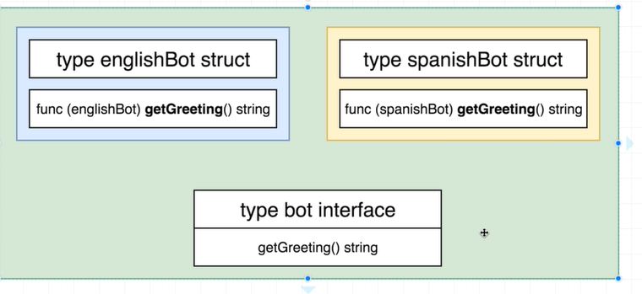

**Complex way**

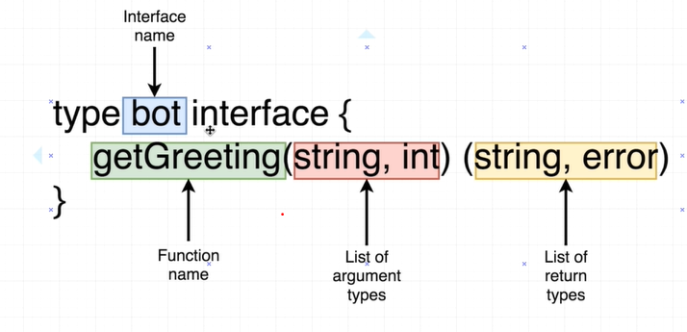

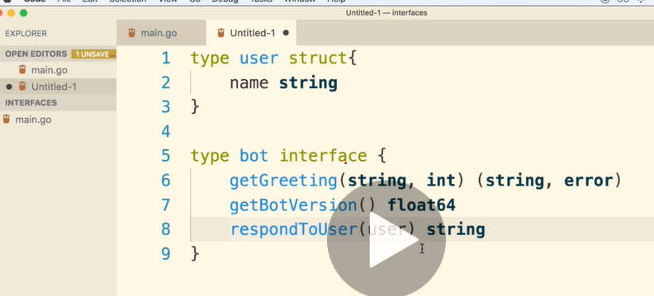

**Concrete type means :** we can create value directly

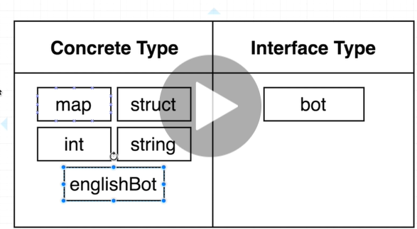

Extra Interfaces Notes

Note : we don’t need to define any link b/w interface struct. It will happen by go that’s why it is called implicit

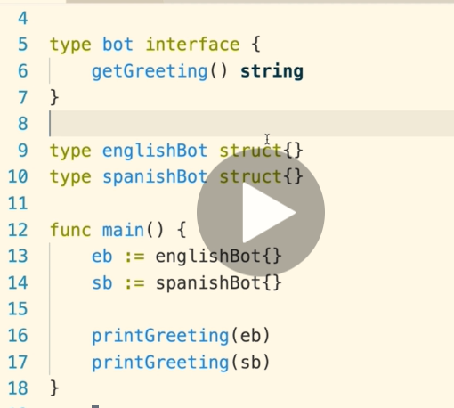

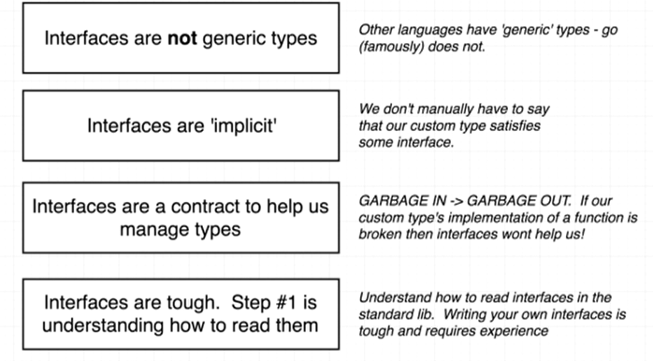

Http Package

How to use interfaces in standard library

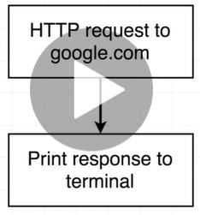

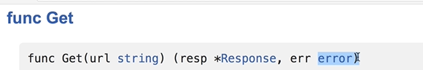

**Note: we don’t see body but getting response**

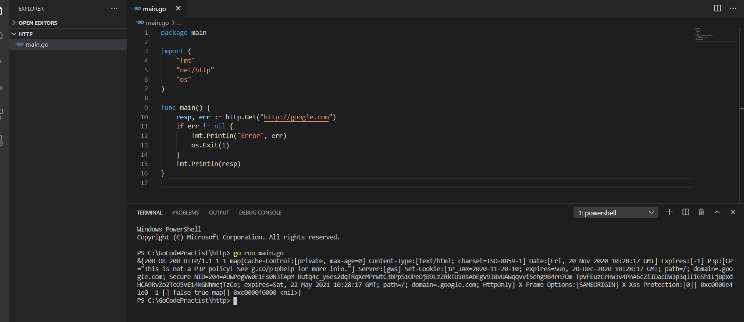

Reading the docs

<https://golang.org/pkg/net/http/#Response> : click on readcloser

<https://golang.org/pkg/io/#ReadCloser> : click on reader

<https://golang.org/pkg/io/#Reader>

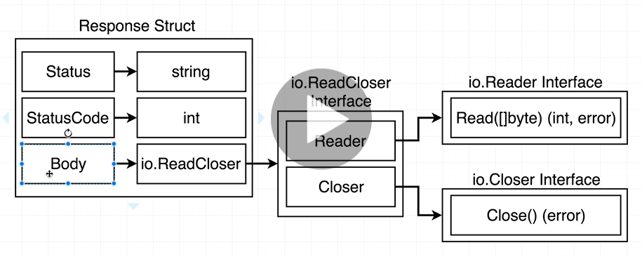

Reader Interface

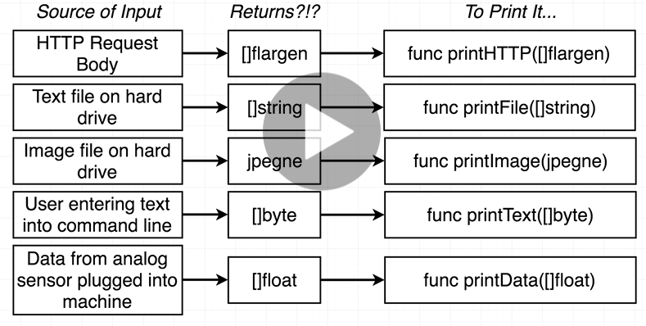

We need to make different function :

**Solution of this: will used reader interface**

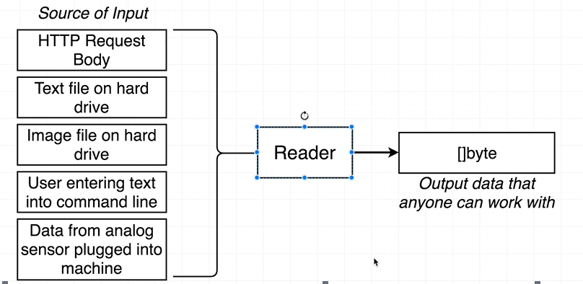

**Note : []byte can be think as a string**

**More on the reader interface**

**Every source of input is going to implement reader interface**

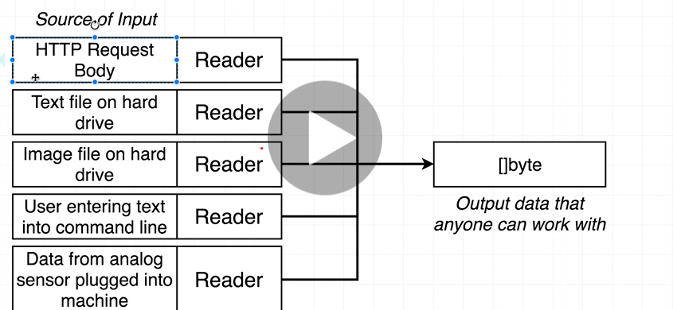

**Question : what read function is doing:-**

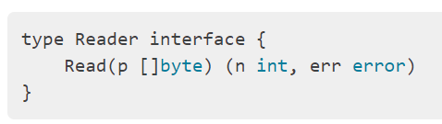

**Note :- Function push raw body into byte slice**

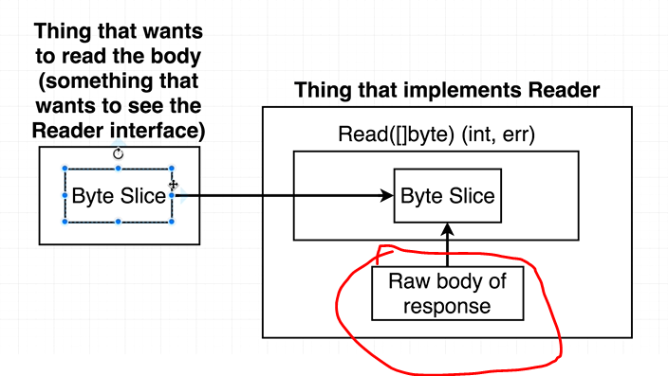

**n: number of bytes read into slice**

**Working with read function**

**// read function will take the data and stick it into empty byte slice**

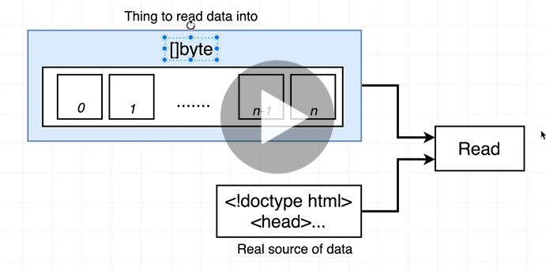

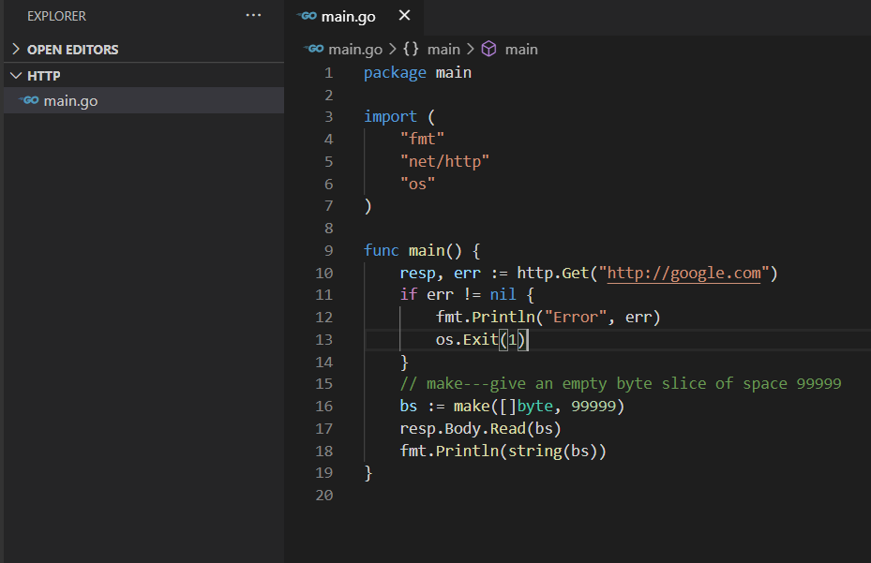

**The writer interface**

**Will give output exactly same as above program give**

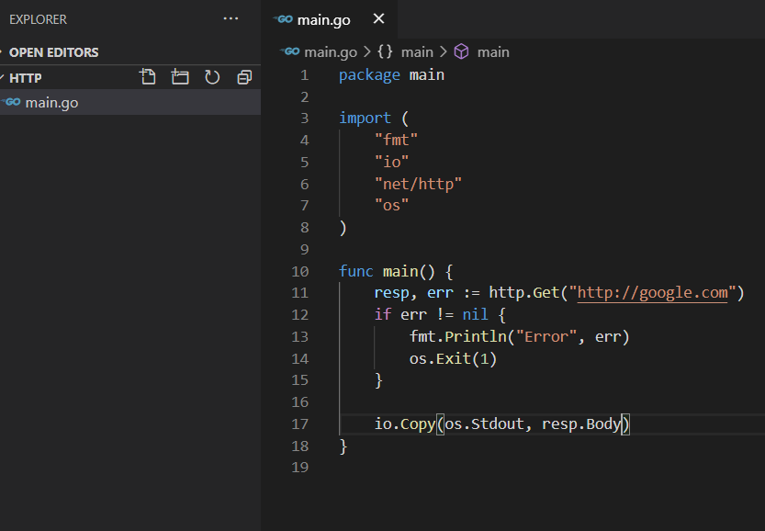

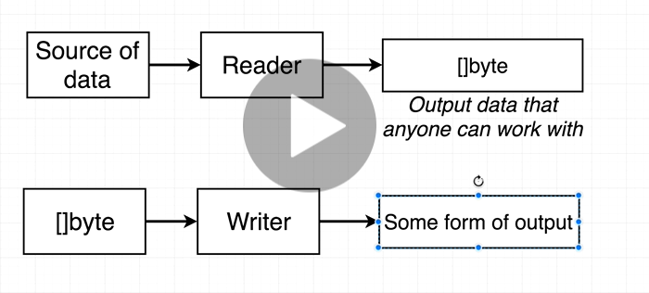

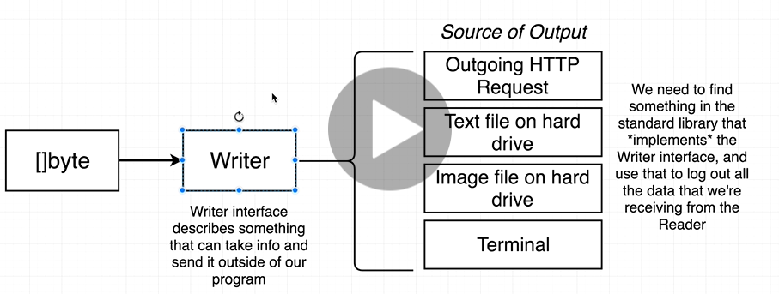

**The io.Copy function**

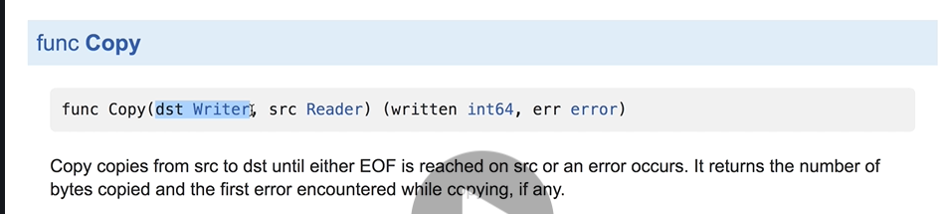

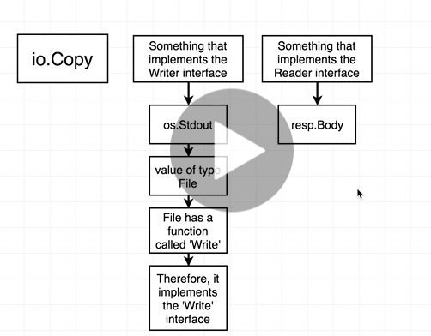

**A Custom writer**

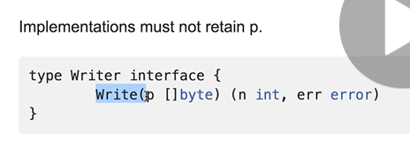

**Note :logWriter implements writer interface**

**Just see reader and writer syntax to understand code**

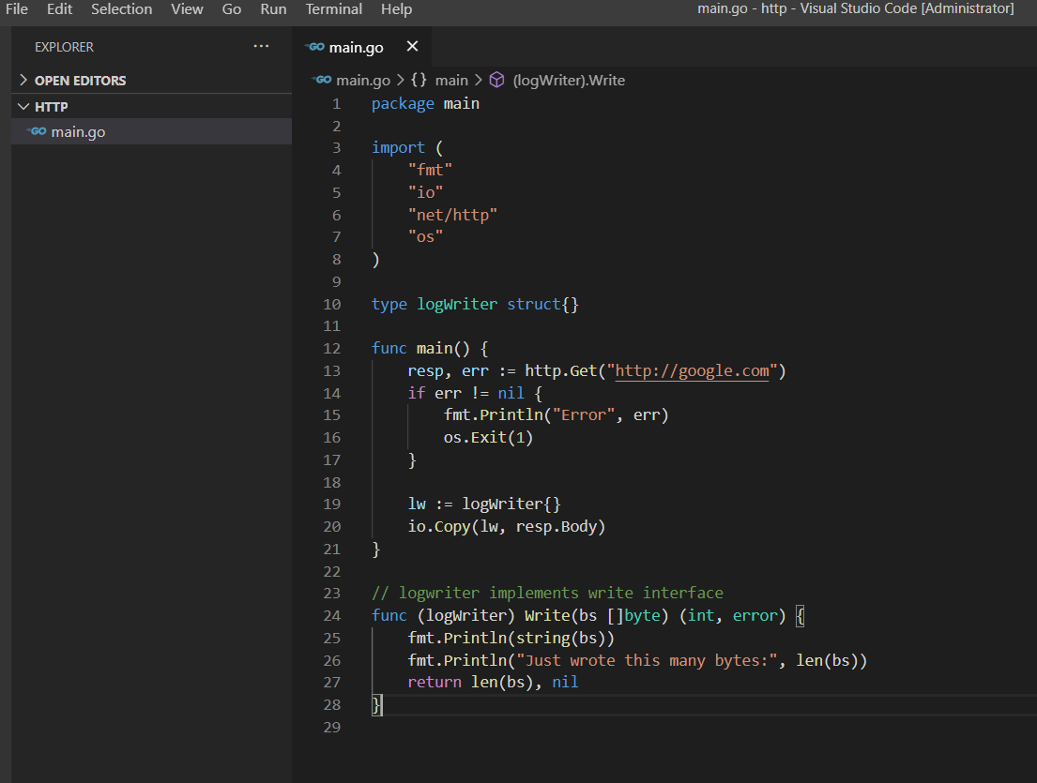

**Section 7 :) Channels and go routine**

**Website status checker**

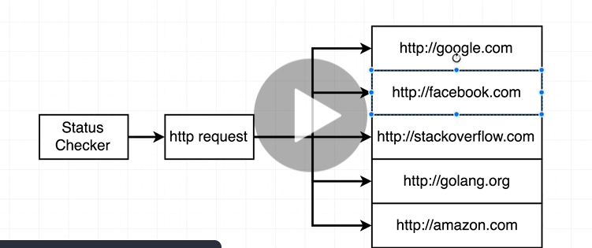

**First will write program in normal way then using golang will resolve problem**

**Note : http.GET ------return response,error**

**Requirement :** to check link is up or down

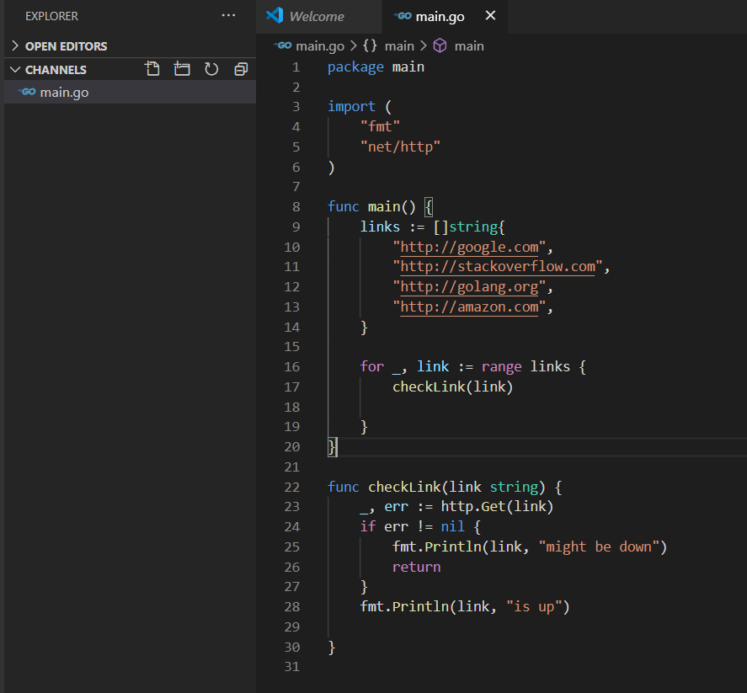

// output is same as the order is print

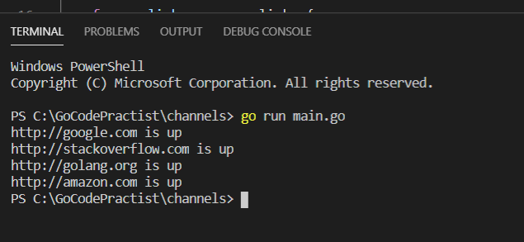

Serial Link checking

**Note** : there is a distinct delay in above output

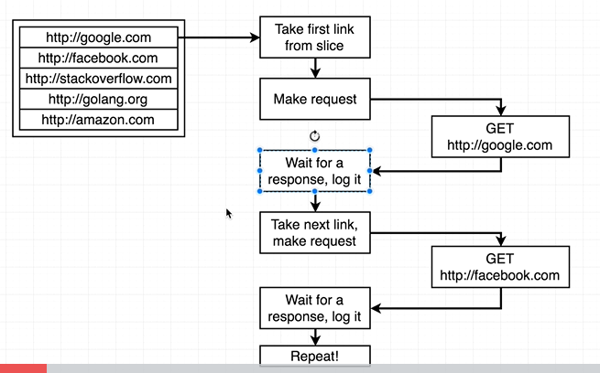

We wait for response to complete it

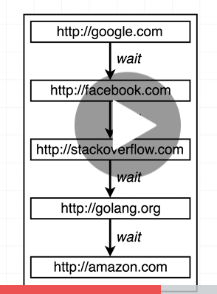

This is not the right approach may be we want to **parallel approach**

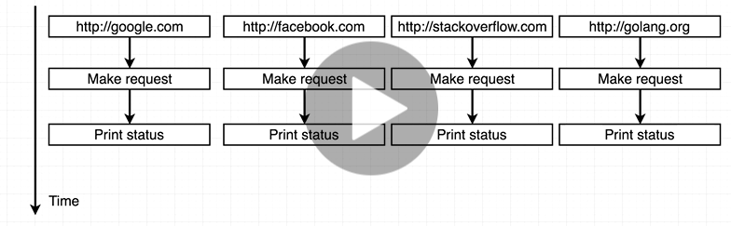

This is where goroutines and channels come into picture

Go Routine

Note :

Go routine execute our code line by line

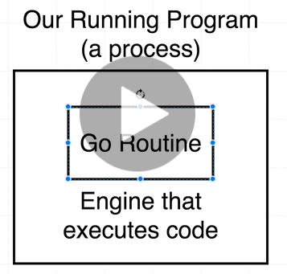

Note : we need to fixed this problem at blocking call

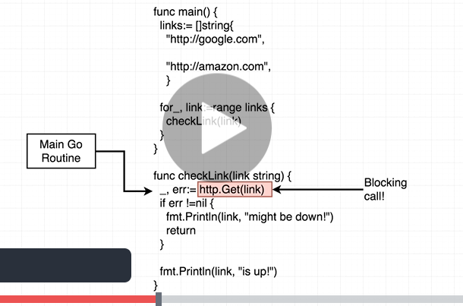

If any blockage is there in code( means it will take some time to execute) then control will go back to check any other go routine is there and this is possible by using go keyword

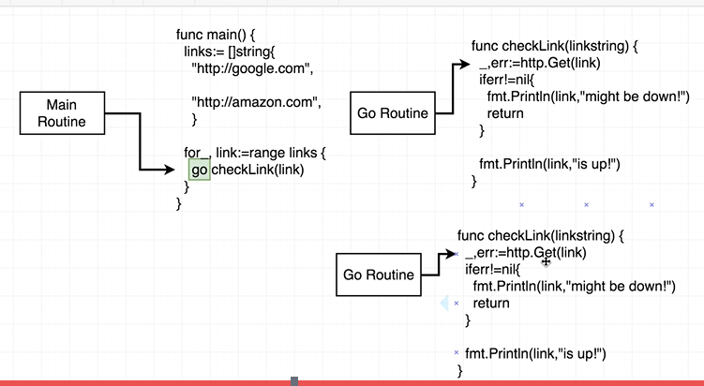

Syntax of go routine

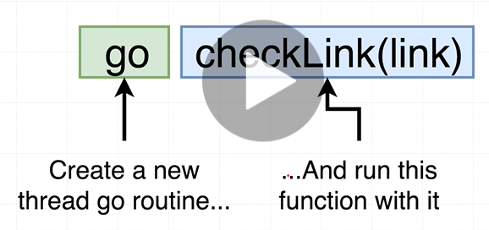

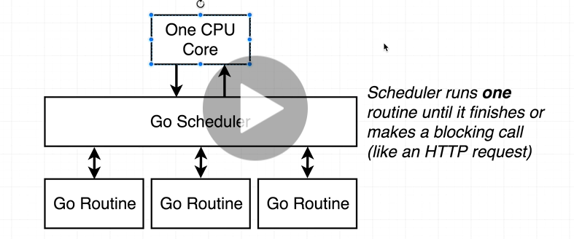

**One cpu core** : go scheduler will run one go routine at a time

**Note :** by default go use one cpu core

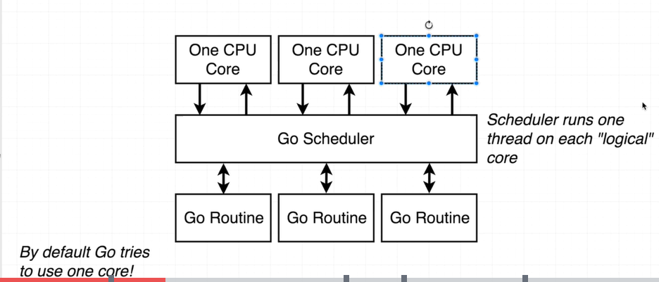

**V imp :**

**Program has the ability to run go routine kind of at same time**

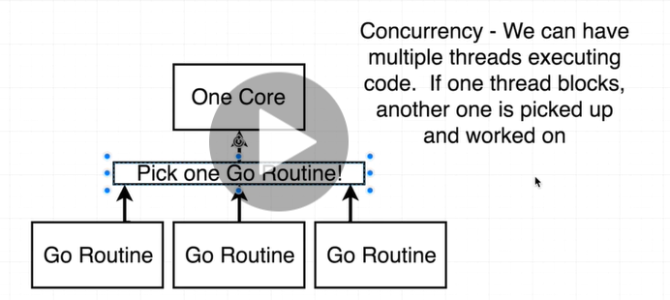

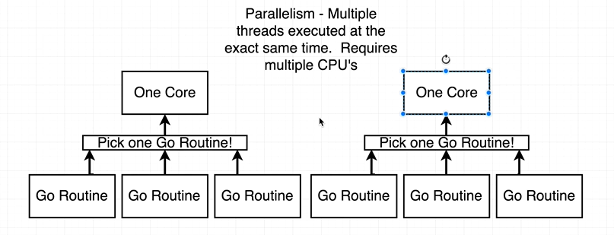

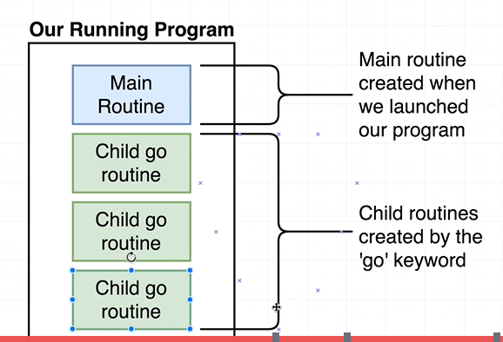

**Channels**

**Requirement : fetch multiple url at same time**

**Remember :** we only use go keyword in front of function call

Note : anytime we are using go keyword we are creating child routine

**Note :** main routine( by default) will not care whether child routine finish or not

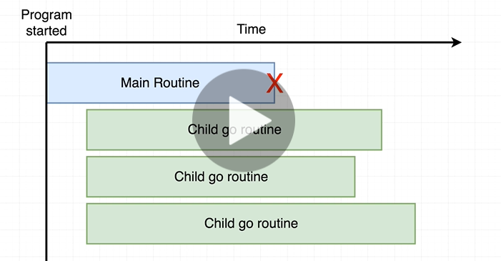

Solution : **channels : are used to communicate between diff go routine**

**Channels are the only way to communicate between go routine**

**Data we pass to go routine from channel must be of same type:**

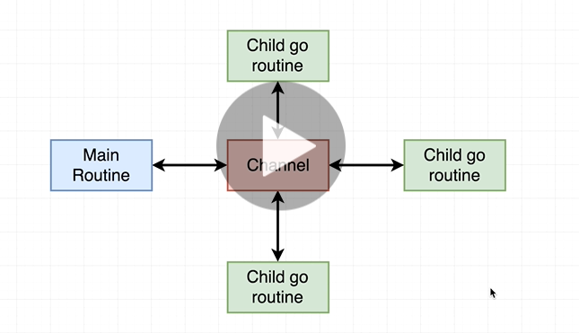

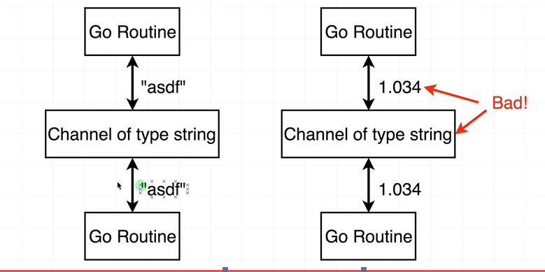

**Channel Implementation**

**Note : once we create channel if all child go routine will finish then only main routine will get finish**

**Program without channel:-**

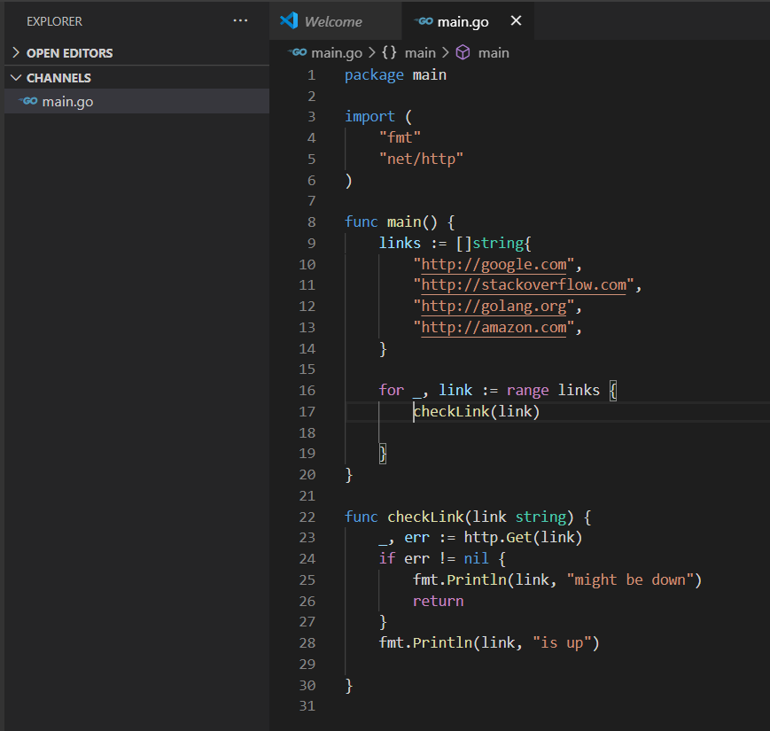

**Note :** we treat channel like any other value

Channel : is sending data ( think like text message)

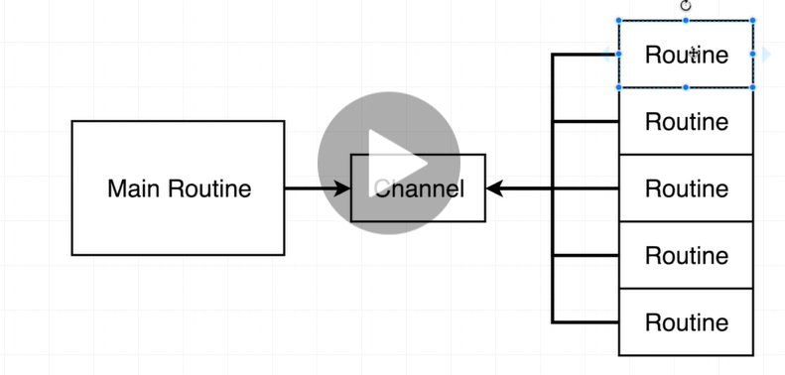

Imp : send value to channel other side will receive value from channel

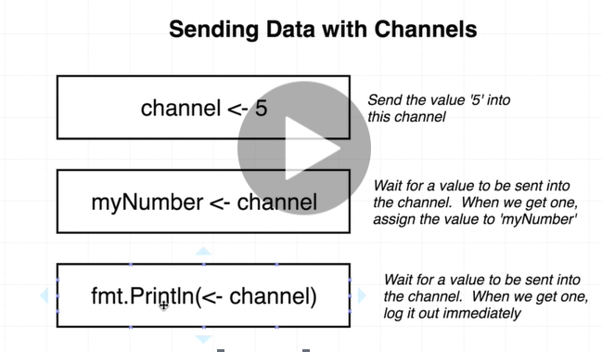

**Note : we can use third one where we don’t need to receive value**

**Note : only one communication over the channel**

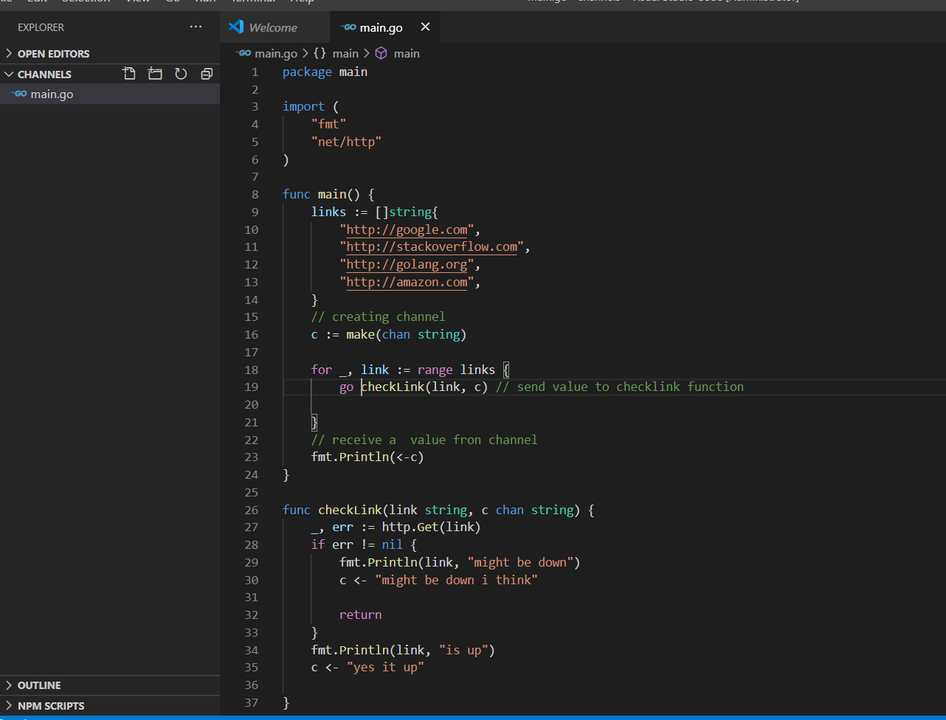

**Output :**

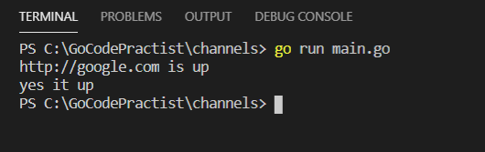

**Blocking channels**

**Main routing will wait to get message from channel once it get first time then it will exit**

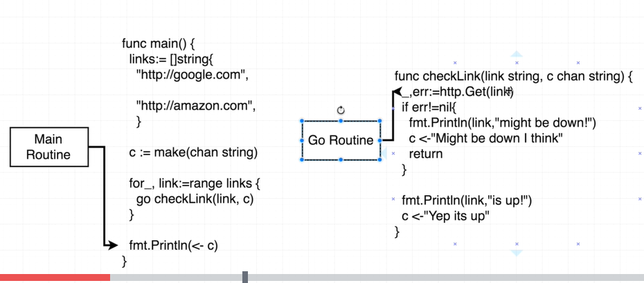

**Note : receiving message from a channel is a blocking line of code**

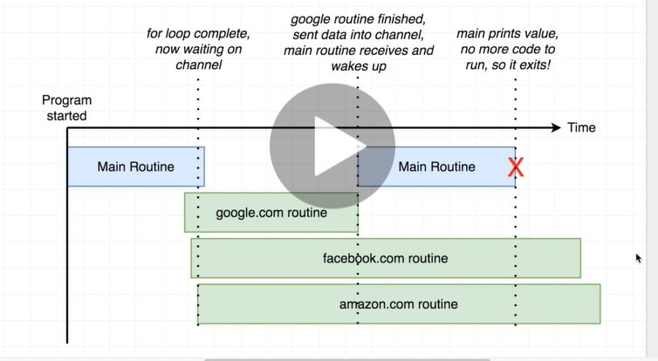

**Fmt.Println(<-c)-----wait for some date to get receive from channel ( means it will go into sleep)**

**//added one more line fmt.Println(<-c)**

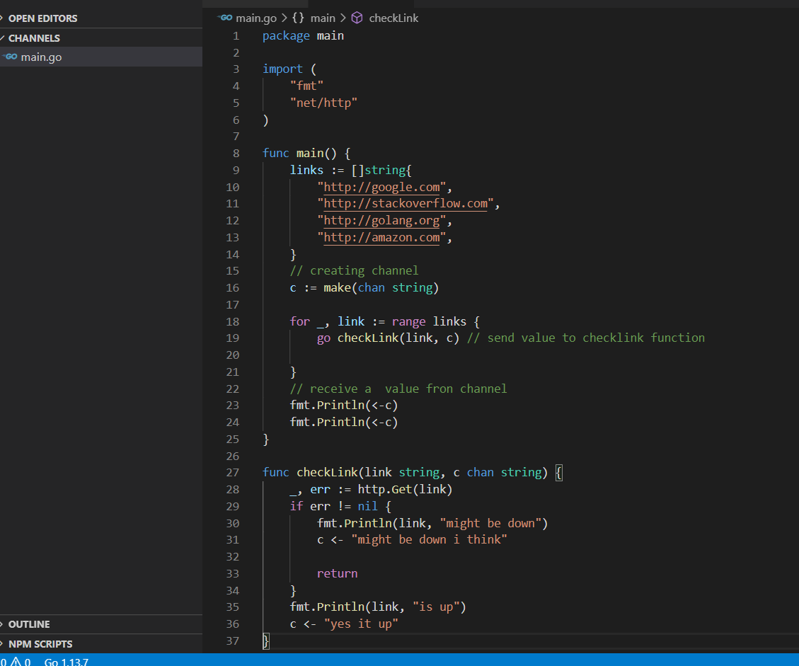

**// output**

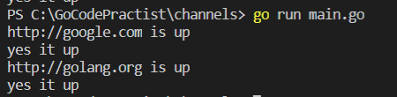

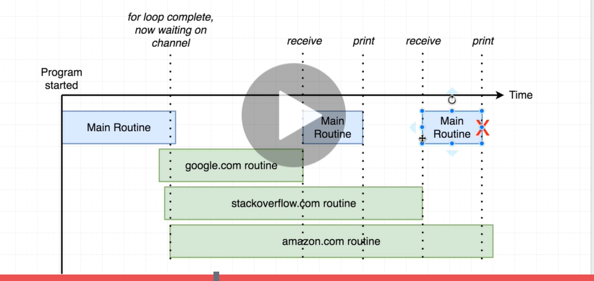

**Note :**

**We don’t want our system to be hanged**

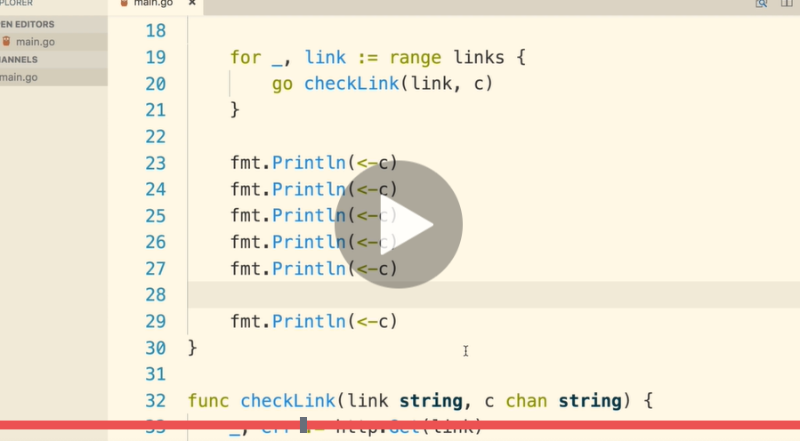

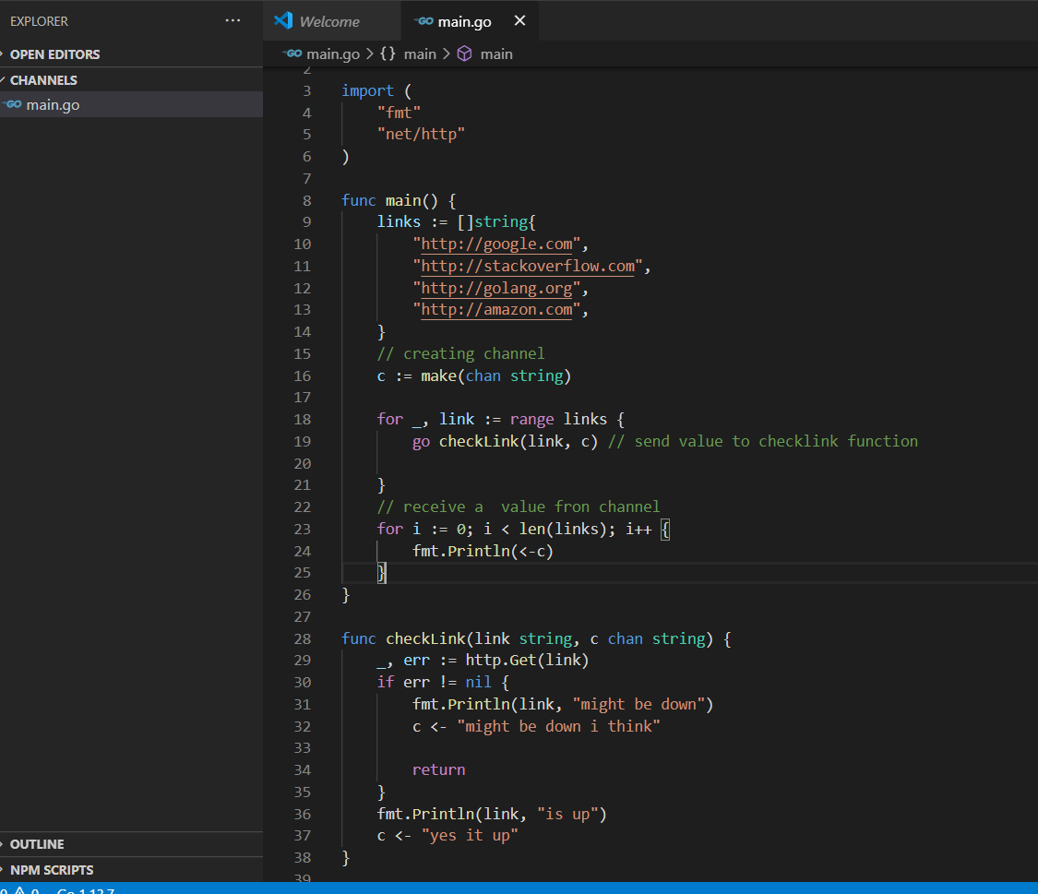

**Repeating Routines**

**Requirement : want to ping each site continuously again and again**

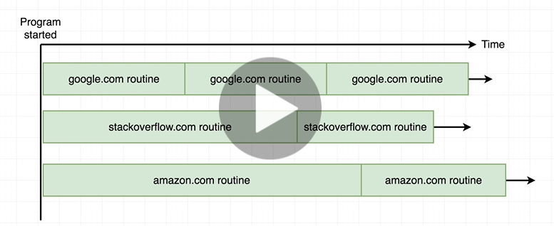

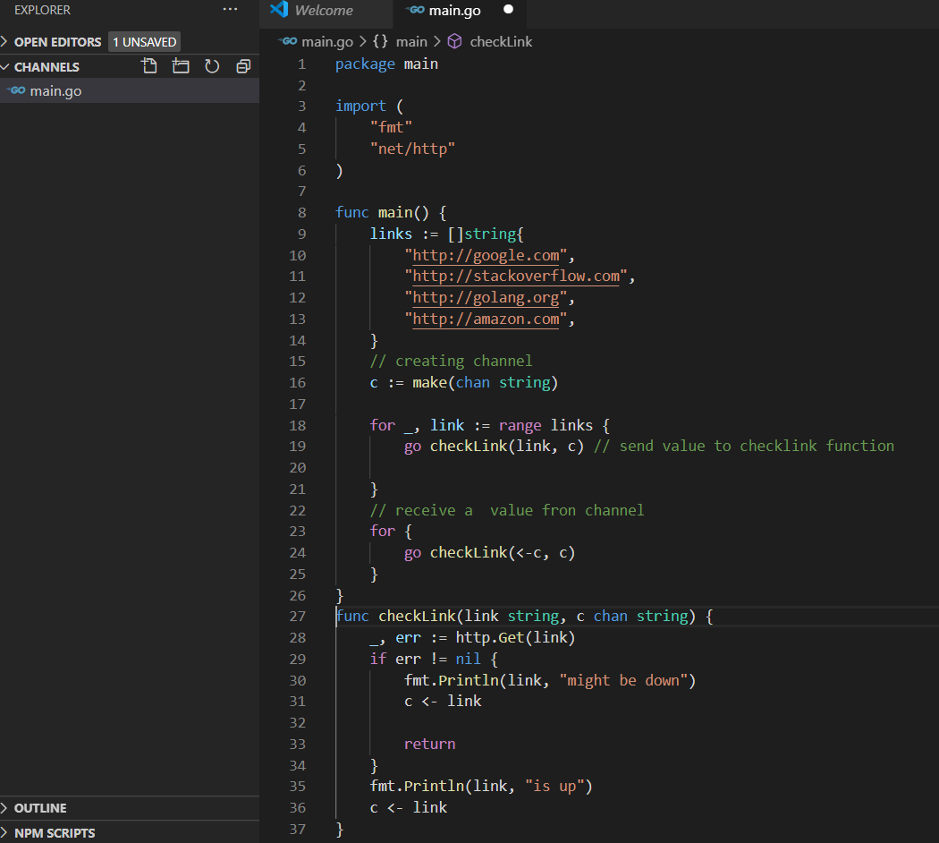

**Alternative loop syntax**

**Requirement : put arbitrary space of time in between each success**

**Equivalent for loop**

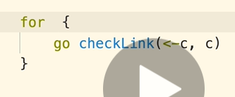

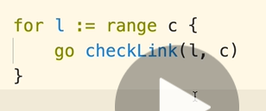

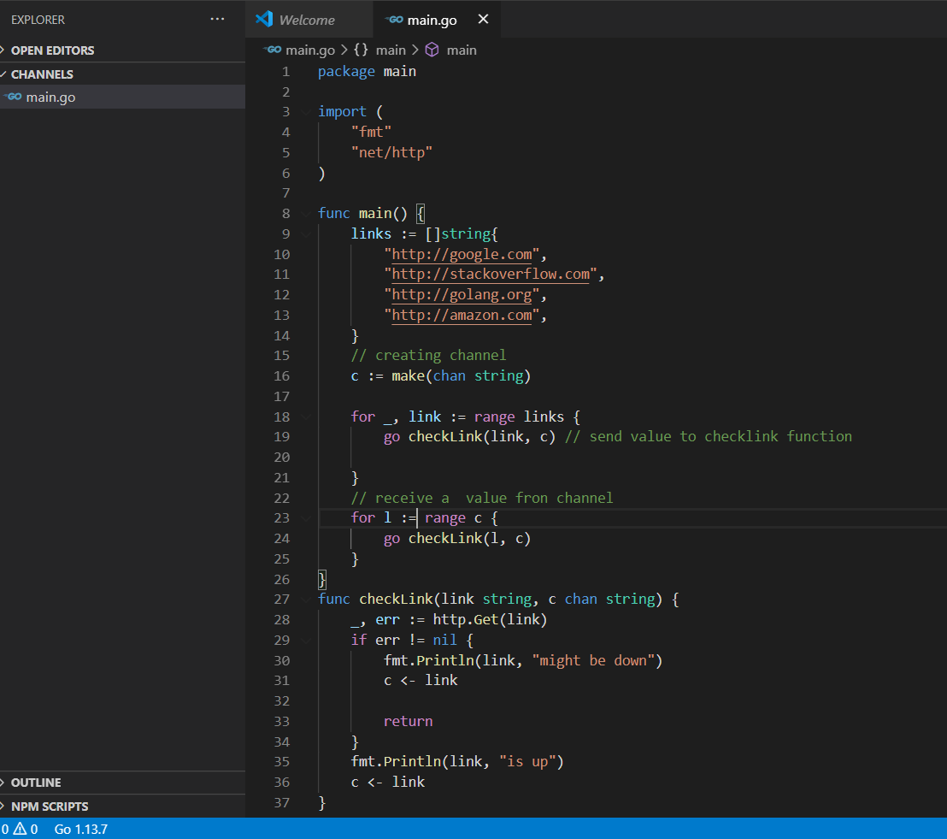

**Sleeping a routine**

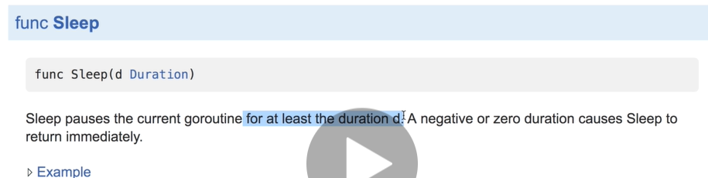

**Note : it is not appropriate to sleep or pause main routine:**

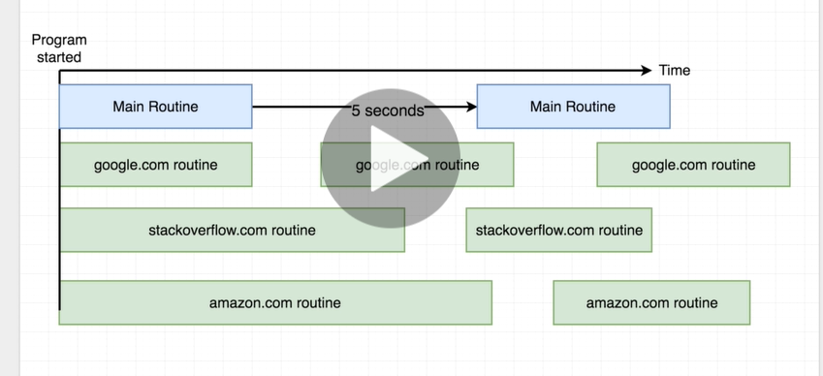

**Note : main routine is always awake and to receive message from channel**

**Function Literal**

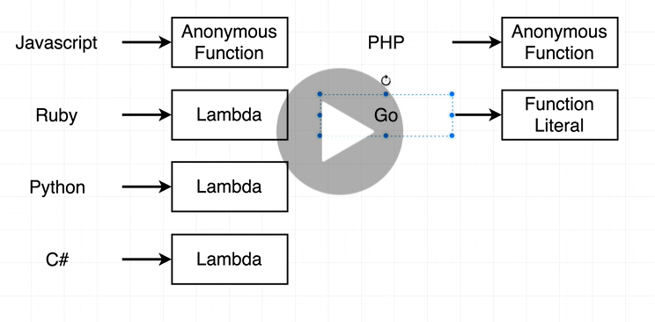

**Function literal : unnamed code (annonymous function) can execute it at some time in future**

**Channels Gotcha**

**Note : we never shared variable b/w main routine and go routine**

